**MOBILE COMPUTING-PROGRESS FILE**

**Submitted to:**

Sir Haq Nawaz

**Submitted by:**

Amber Shafique (Bsef18a019)



____________________________________________________________

**PUCIT, University of the Punjab, Lahore.**

**LECTURE#1**

* **VCS (Version Control System):**

A **version control system** is a kind of software that helps the developer team to efficiently communicate and manage track of all the changes that have been made to the source code along with the information like who made and what change has been made.

* Version control software keeps track of every modification to the code in a special kind of database.
* Using a VCS also generally means that if you screw things up or lose files, you can easily recover

**Benefits:-**

1. **Code Synchronizing:** Same code available to all members on different repositories connected to a central repository. All the changes in the files are tracked under the central repository. The central repository includes all the information of versioned files, and list of users that check out files from that central place using **VCS.**
2. **Code Testing :VCS** helps to test changes without losing the original version of the application.
3. **Revert: VCS** allows us to revert back to previous versions of the file because it separately maintains each version of file.

* **Git :**

Git is software for tracking changes in any set of files, usually used for coordinating work among programmers collaboratively developing source code during software development.

**Step-0**

**1.1 GitHub Account:**

Sign up to ***github.com*** and create a new account.

**1.2 Git CMD:**

Install git cmd and configure it on your PC.

**Step-1**

**1.1 Create a new Repository:**

**1.1.1** Click on add new repository button on your GitHub account.

|  |
| --- |
|  |

**1.1.2** Then provide details of your repository => Name, Description,Type.

**Public Repository:** It is visible to every user on your GitHub.

**Private Repository:** It is only available to the repository owner.

**1.1.3** Click on the create repository button.

|  |
| --- |
|  |

**1.2 Repository URL :** On creating a new repository GitHub will provide its url that is used to uniquely identify our repository on GitHub.

|  |
| --- |
|  |

**LECTURE#2**

* **Git Clone:**
* It is primarily used to point to an existing repository and make a clone or copy of that repository in a new directory, at another location.
* Makes connection between **local repository(**on PC) and **central repository** (on GitHub).

**Step-1**

Open **git CMD** and go to that folder path (using **cd**) where you want to clone the repository.

**Step-2**

Run the following command and give the **git url** of the repository you want to clone locally.

|  |
| --- |
| **git clone URL** |

|  |
| --- |
|  |

Repository cloned Locally (see using **dir**)

|  |
| --- |
|  |

* **Add File:**

Add locally created file to the central(online) repository.

**Step-1**

Creating file in local repository.

|  |
| --- |
|  |

**Step-2**

Run the following command and give the **File Name** you want to add on git repository.

|  |
| --- |
| **git add FileName** |

No error, so file has been added successfully.

|  |
| --- |
|  |

* **Add all files :**

|  |
| --- |
| * **git add --all** * **git add .** |

* **Add multiple files at same time:**

|  |
| --- |
| **git add FileName FileName FileName ...** |

* **Git Commit**

The "commit" command is used to save your changes and track messages.

**Step-3**

Run the following command and give the **Message** you want to get displayed with added file.

|  |
| --- |
| **git commit -m “message”** |

Message=> to inform the users about the change.

|  |
| --- |
|  |

* **Add and commit simultaneously**

|  |
| --- |
| **git commit -am “message”** |

* **Git Push:**

To push the changes made in file locally to server (online repository).

**Step-4**

Run the following command to complete the synchronization.

|  |
| --- |
| **git push** |

**Now we are synchronized with data available on local disk and online repository.**

|  |
| --- |
|  |

Check the status of the online repository by refreshing the GitHub Repository URL.

|  |
| --- |
|  |

Content in online and local repository is synchronized.

|  |
| --- |
|  |

* **Git Status:**

Gives the status of repository.

|  |
| --- |
| **git status** |

|  |
| --- |
|  |

**Making change in file locally using IDE:**

Whenever we make any change in file locally editor will show some change message

|  |
| --- |
|  |

* **Adding New Commit (To save locally made changes online) :**

Run these previously discussed commands on git CMD in sequence.

**Step-1**

|  |
| --- |
| **git add FileName** |

**Step-2**

|  |
| --- |
| **git commit -m “message”** |

**Step-3**

|  |
| --- |
| **git push** |

|  |
| --- |
|  |

**Track of Changes:**

To preview change online refresh the repository url and see the changes have been made.

|  |
| --- |
|  |

* **Editing a file online in github repository:**

**Step-1**

Edit the file online using the edit button on file.

|  |
| --- |
|  |

**Step-2**

Save commit changes.

|  |
| --- |
|  |

* **Git Pull:**

To get Changes from GitHub to local repository.

**Step-1**

After making changes online, run the following command on git CMD.

|  |
| --- |
| **git push** |

Changes have been made to local repository.

|  |
| --- |
|  |

* **Version Hierarchy:**

File showing with latest commit.

* **Red Highlighted lines:** The lines that have been deleted.
* **Green Highlighted lines:** The lines that have been changed.

|  |
| --- |
|  |

Parents=> previous versions of file.

|  |
| --- |
|  |

**LECTURE#3**

* **Merge Conflicts:**

A merge conflict is an event that takes place when Git is unable to automatically resolve differences in code between two commits. Git can merge the changes automatically only if the commits are on different lines or branches.

**Step-1**

Changes in lin-8 online.

|  |
| --- |
|  |

**Step-2**

Changes in same line-8 locally.

|  |
| --- |
|  |

**Step-3**

Run commands step by step to save file changes in git CMD.

Merge Conflict has occurred because we are trying to change the same line locally and in online repository.

|  |
| --- |
|  |

**Step-4**

Open the file in IDE to see the conflict and given options.

|  |
| --- |
|  |

**Step-5**

Accept Change and resolve the merge conflict and **again** Run commands step by step to save file changes in git CMD.

Now changes have been saved successfully as conflict is resolved.

|  |
| --- |
|  |

* **Git Logs:**

To see the details of all commits.

|  |
| --- |
| **git log** |

|  |
| --- |
|  |

* **Remove a File:**

Files already present

|  |
| --- |
|  |

**Step-1**

To remove file type the following command on git CMD, and give the name of file you want to delete.

|  |
| --- |
| **git rm FileName** |

File deleted locally

|  |
| --- |
|  |

Now to update delete changes to git:

**Step-2**

|  |
| --- |
| **Git add .** |

**Step-3**

|  |
| --- |
| **git commit -m “message”** |

**Step-4**

|  |
| --- |
| **git push** |

|  |
| --- |
|  |

Preview delete changes on GitHub

|  |
| --- |
|  |

* **Branching:**

Branching is the practice of creating copies of programs or objects in development to work in parallel versions, retaining the original and working on the branch or making different changes to each.

**Step-1**

**Git Branch:**

Run the following command on cmd to check available branches.

|  |
| --- |
| **git branch** |

**Step-2**

**Git Checkout:**

To create a new branch, type the following command on git CMD and give the name of branch.

|  |
| --- |
| **git checkout -b newbranch** |

|  |
| --- |
|  |

Branch Added on GitHub

|  |
| --- |
|  |

**Step-3**

**Git Checkout Master:**

To navigate from one branch to another. (master=>branch name )

|  |
| --- |
| **git checkout master** |

|  |
| --- |
|  |

**To Check Branching:**

**Step-1** Add changes to a file on master branch.

**Step-2** Move to new branch and add file on the new branch.

**Step-3** Checkout file on both branches and see the changes accordingly on IDE.

New branch showing changes...

|  |
| --- |
|  |

Master branch showing previous version without changes...

|  |
| --- |
|  |

* **Merging:**

Merging is Git's way of putting a forked history back together again. The git merge command lets you take the independent lines of development created by git branch and integrate them into a single branch.

**Merge Branch:**

To merge the changes in branches.

|  |
| --- |
| **Git merge branchname** |

|  |
| --- |
|  |

* **Delete Branch:**

To delete a branch.NewBranch=>you want to delete.

|  |
| --- |
| **Git branch -D NewBranch** |

Checking out branches before and after deletion...

|  |
| --- |
|  |

|  |  |
| --- | --- |
| Before Deletion | After Deletion |

**LECTURE#4**

* **Android Studio:**

Android Studio is the official Integrated Development Environment (IDE) for Android app development, based on IntelliJ IDEA. A unified environment where you can develop for all Android devices. Apply Changes to push code and resource changes to your running app without restarting your app.

**Step-1**

**Installation:**

Download any latest version of **Android Studio** and configure it on your PC. **(**[**https://developer.android.com/studio**](https://developer.android.com/studio)**)**

**Step-2**

**Create a New Project:**

Open Android Studio and select the option to create a new project.

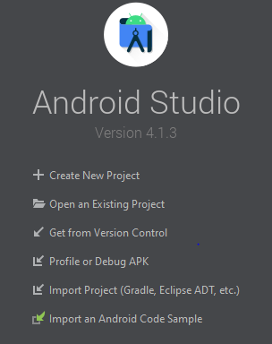

**Step-3**

**Template Selection:**

From templates choose Empty Activity.

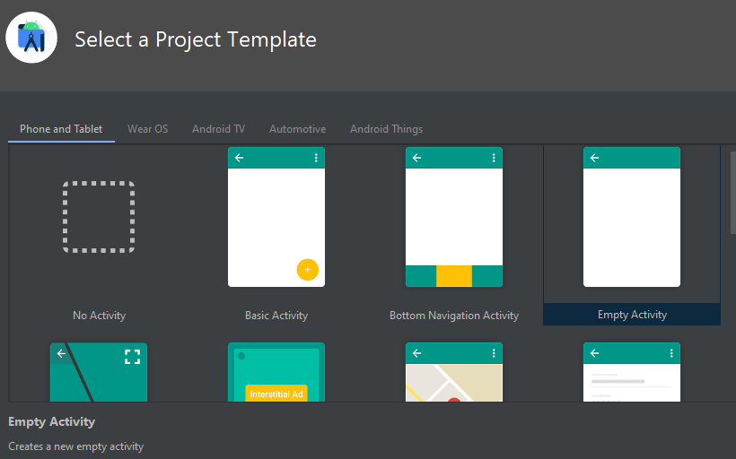

**Step-4**

**Project Name:**

Select a name and location for project for project.

**Package Name:**

It is used to uniquely identify the APK file of our application and it should must be unique to publish the App on play store.

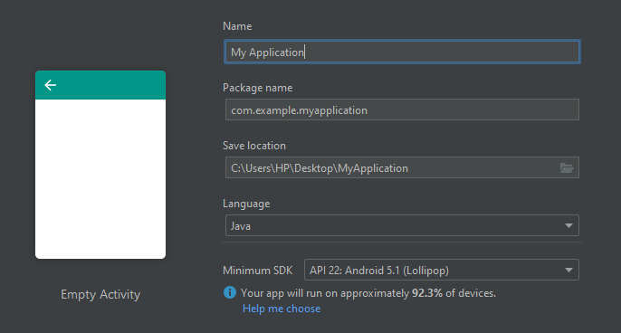

**Package Name Example:**

Here package name is (**com.facebook.lite**)

|  |
| --- |
|  |

* **Android Studio File Structure:**

|  |  |
| --- | --- |
| Android view  (used by default) | Project view |

**Files for coding:**

* **MainActivity.java** file for coding.

|  |
| --- |
|  |

**Activity_main.xml** file for Graphical user interface(**GUI**).

|  |
| --- |
|  |

**Step-4**

**Select Virtual Device:**

Select **Virtual Devices** from AVD(Android Virtual Device) Manager to view output.

**Step-4**

**To view output:**

Run the **Emulator** choosing any virtual device and see the output.

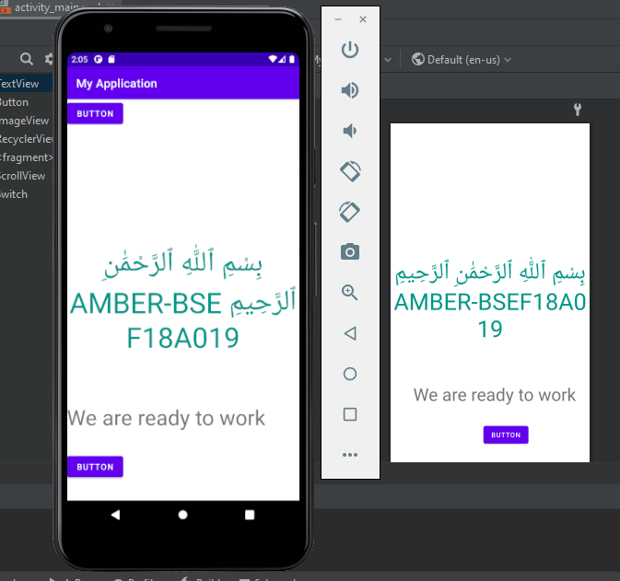

**To Do list:**

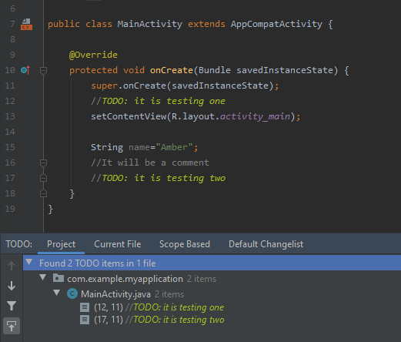

**Design Palette:**

We can add text,Button,image and other controls by using drag and drop from this palette.

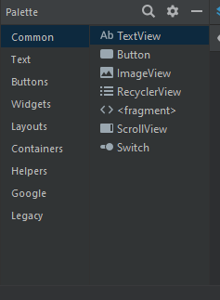

**Attributes:**

To set the values of elements added in xml.

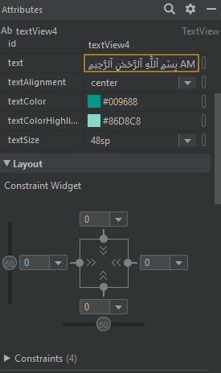

* **Multiple Screen Task:**

**Screen-1**

**Step-1** Add elements of text box and buttons on the screen from palette by drag and drop.

|  |  |
| --- | --- |
| **XML View**  **_________________________** | **Emulator View**  **____________________________________** |

**Screen-2**

**Step-2** Adding more elements of plain text and password to take input.

|  |  |
| --- | --- |
| **XML View**  **_________________________** | **Emulator View**  **____________________________________** |

**Screen-3**

**Step-3** Setting constraints and others attributes to each element to set the screen presentation.

|  |  |
| --- | --- |
| **XML View**  **_________________________** | **Emulator View**  **____________________________________** |

**Final Screen view taking input:**

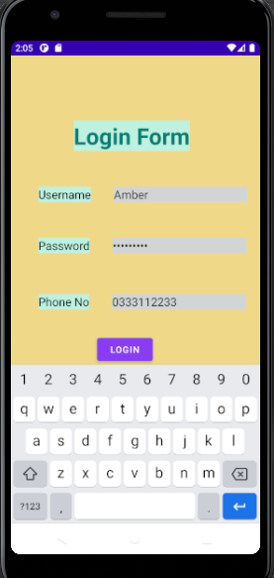

**LECTURE#5**

* **View Group:**

A ViewGroup is an **invisible container**. It is a special view that can contain other views (called children.)

* **Layouts:**

View group objects are called **“layouts”** can be one of many types that provide a different layout structure, such as LinearLayout or ConstraintLayout .

* **View:**

View is the basic building block of **UI**(User Interface) in android. View refers to the android. view. View class, which is the super class for all the GUI components like TextView, ImageView, Button etc. It draws something that user can see and interact with.

* **Widgets:**

The View objects are usually called **"widgets"** and can be one of many subclasses, such as Button or TextView.

|  |
| --- |
|  |

**Root Element:**

Each layout file must contain exactly one **root element**, which must be a **View or ViewGroup** object. Once you've defined the root element, you can add additional layout objects or widgets as child elements to gradually build a View hierarchy that defines your layout. For example, here's an XML layout that uses a vertical LinearLayout to hold a TextView and a Button.

**Constraint Layout** is the root element by default.

|  |
| --- |
|  |

* **Layouts Practice:**

**Step-1** Create a new project with empty template.

**Step-2** Add a new resource file.

|  |
| --- |
|  |

**Step-3** Select the root element of **LinearLayout**.

|  |
| --- |
|  |

**Step-4**  Add a text view and button, and you will see that these elements are displayed in a linear layout on xml design view.

|  |
| --- |
|  |

* **Load XML Resources:**

**Step-5** In MainActivity.java file change the **setContentView(R.layout .___)**, to the layout file you want to run on emulator.

|  |
| --- |
|  |

**Layout Parametres:**

They are used by views to tell their parents how they want to be laid out.

* **Constraint Layout:**

In Constraint Layout, you can connect all the view components to each other and place them on screen.

* To define a **view's position** in ConstraintLayout , you must add at least one horizontal and one vertical constraint for the view. Each constraint represents a connection or alignment to another view, the parent layout, or an invisible guideline.

**Clear All constraints:**

**Step-1** Select all on xml design layout by **ctrl+a**

**Step-2** Select the option Clear All constraints.

|  |
| --- |
|  |

* **Adding Image in Android Layout:**

**Step-1** In drawable paste any image from your system

**Step-2** Add an image view from palette and select the image you want to add.

|  |
| --- |
|  |

|  |
| --- |
|  |

* **Adding buttons with alignment:**

|  |
| --- |
|  |

* **Buttons using Layout Constraint Center-Horizontally:**

Reminder place details

|  |
| --- |
|  |

|  |  |
| --- | --- |
|  |  |

* **Making Instances for buttons:**

Reminder place details

**LECTURE#6**

* **Activity:**

An Activity is an application component that represents one window, one hierarchy of views.

* Typically fills the screen, but can be embedded in other Activity or appear as floating window.
* Java class, typically one Activity in one file.
* **Intent:**

An intent is to perform an action on the screen. It is mostly used to start activity, send broadcast receiver,start services and send message between two activities.

**To Set Constraints Automatically:**

**Step-1** Use the highlighted tool to set constraints automatically.

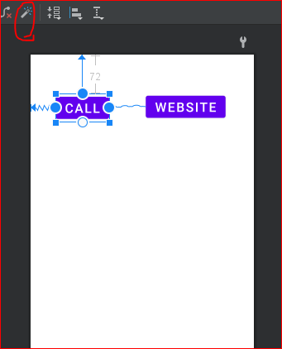

**To define String Resources:**

**Step-2** Click on the fixes button and set a string name for the element.

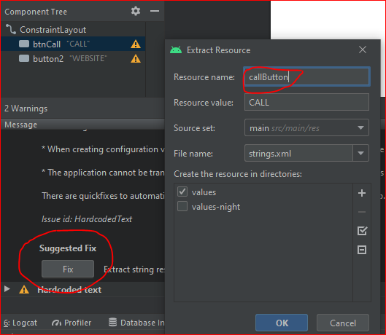

* **The string name will be defined in string.xml file that is**

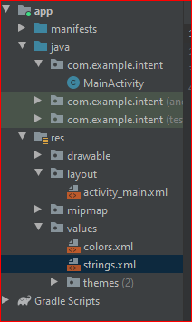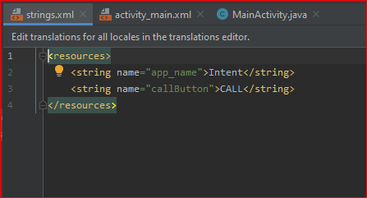

* **Intent Uses**

1. **To open Website using Intent:**

|  |
| --- |
| **Uri uri=Uri.*parse*("https://github.com/amber-shafique");**  **Intent intent=new Intent(Intent.*ACTION_VIEW*,uri);**  **startActivity(intent);** |

**Step-1** Add the above code onClick instance of button.

**Step-2** Click on the website button on click of which you have added intent to open website.

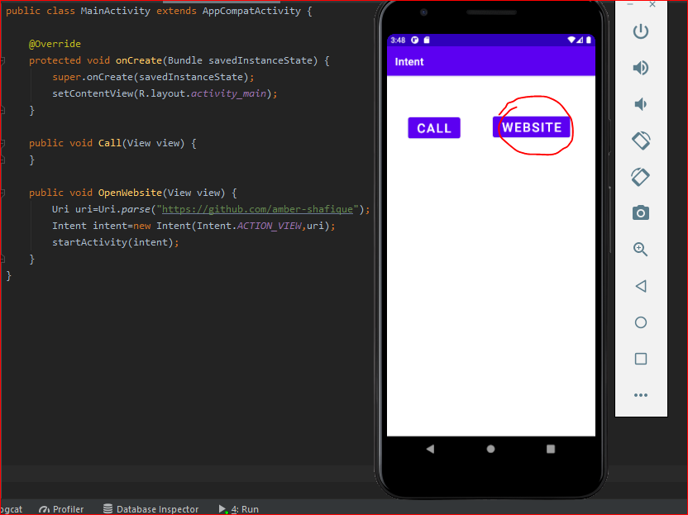

* Just after Clicking the **website** button , the url will open

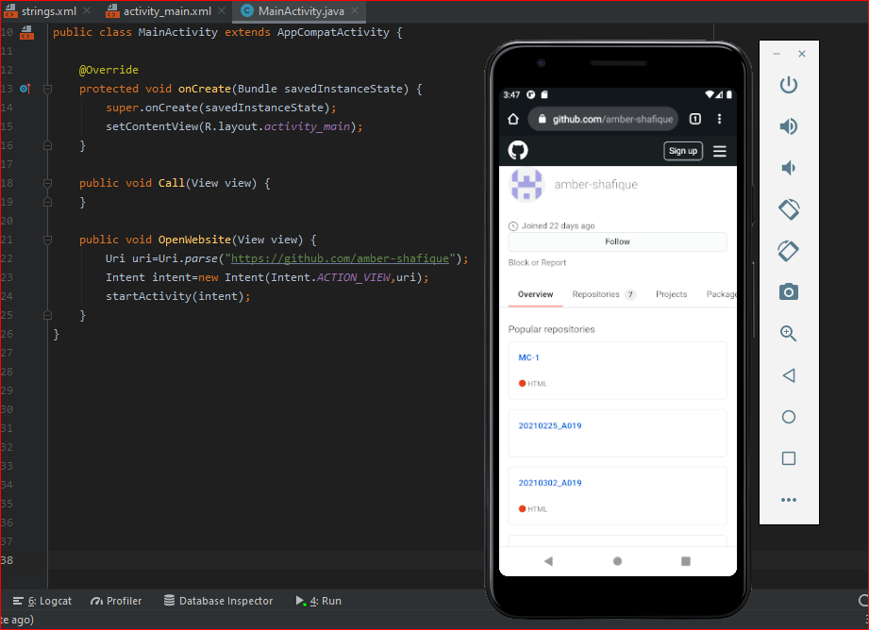

1. **To Dial a Call using Intent:**

|  |
| --- |
| **Uri uri=Uri.*parse*("tel: +923485677744");**  **Intent intent=new Intent(Intent.*ACTION_DIAL*,uri);**  **startActivity(intent);** |

**Step-1** Add the above code onClick instance of button.

**Step-2** Click on the website button on click of which you have added intent to open call dialer.

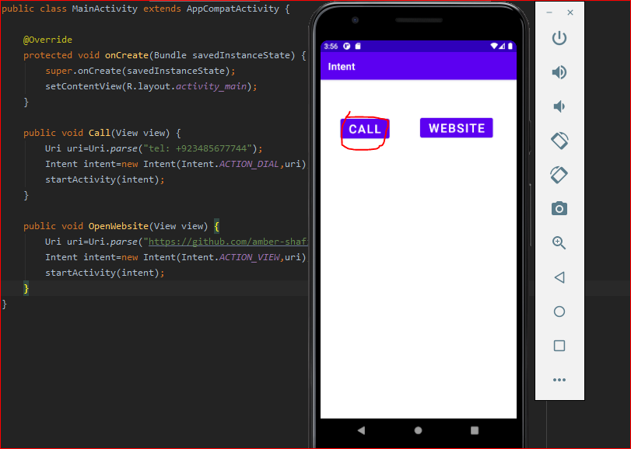

* Just after Clicking the **call** button , the call dialer will open

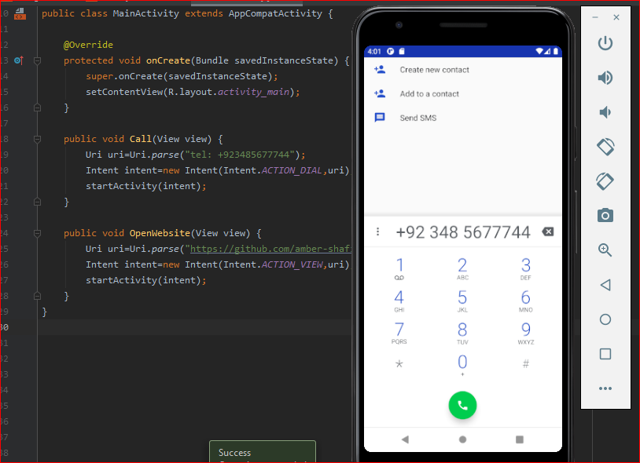

* **Setting another Activity as Launcher Activity:**

By default launching activity in **AndoidManifest.xml** file.

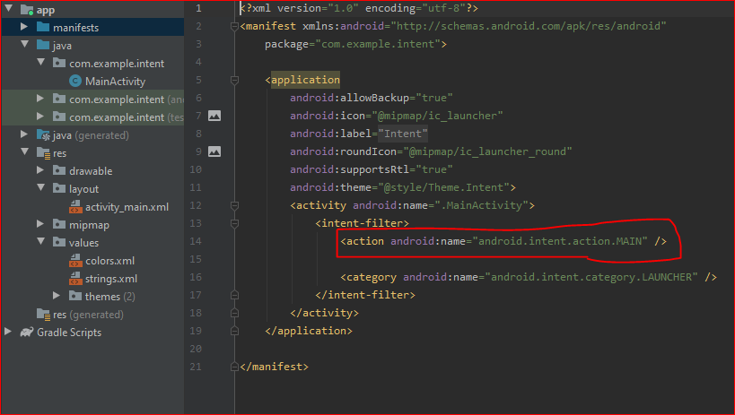

Create a new activity and check its attribute of **Launcher Activity.**

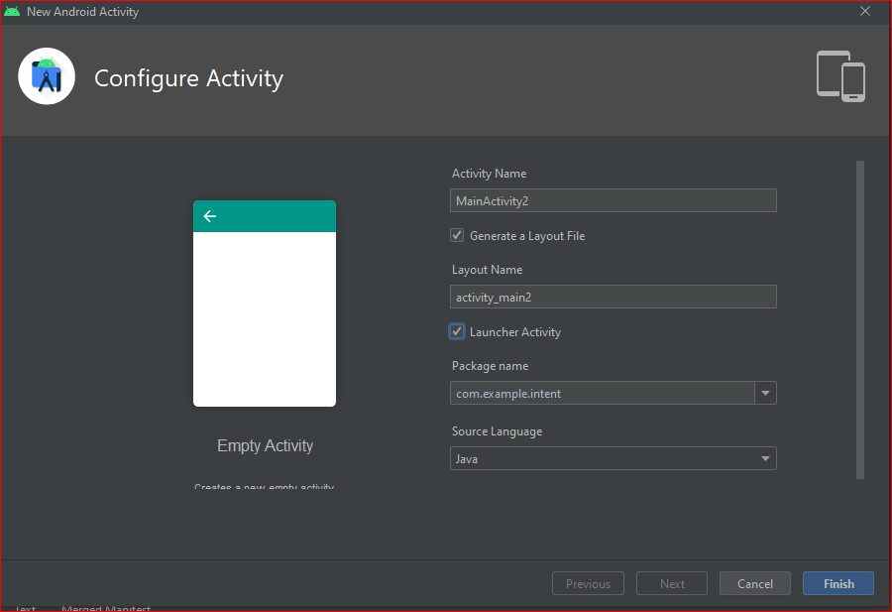

Launcher Activity changes in **AndoidManifest.xm**l file

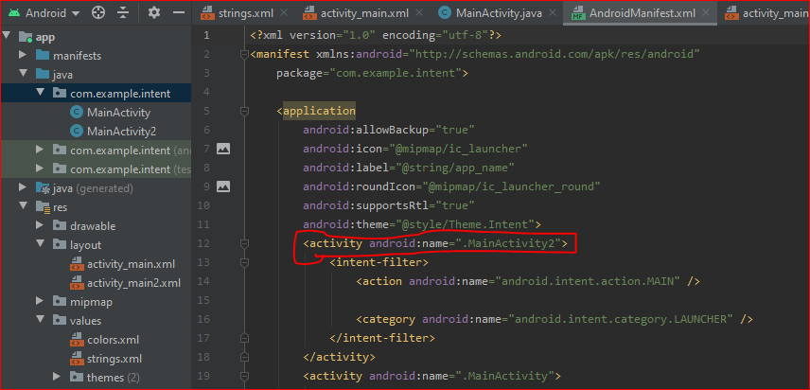

1. **To move from one activity to another:**

this=> present activity

ActivitName.class=> activity where to move

|  |
| --- |
| **Intent intent=new Intent(this, MainActivity.class);**  **startActivity(intent);** |

**Step-1** Add the above code onClick instance of button.

**Step-2** Click on the website button on click of which you have added intent to open another activity..

* Just after Clicking the **Move Activity One** button , the second activity will open.

|  |  |
| --- | --- |
| **First activity** | **Second activity** |

**LECTURE#7**

* **Counter:**

Adding code to display a counter on screen.

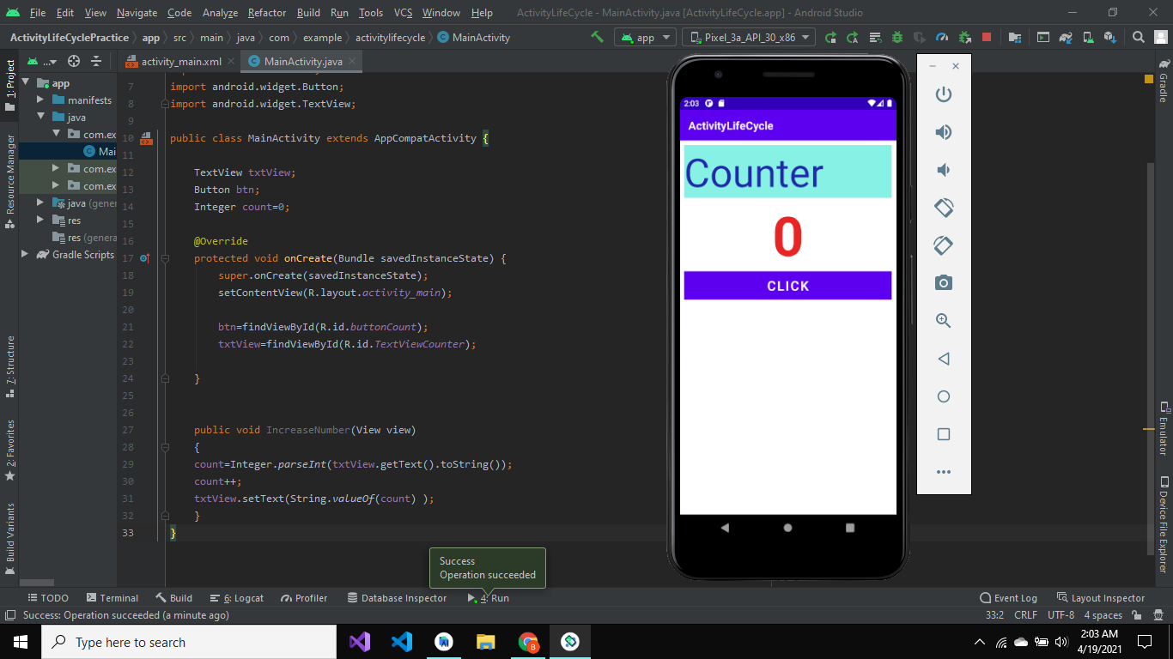

Click on the button to increase value of counter and see the result.

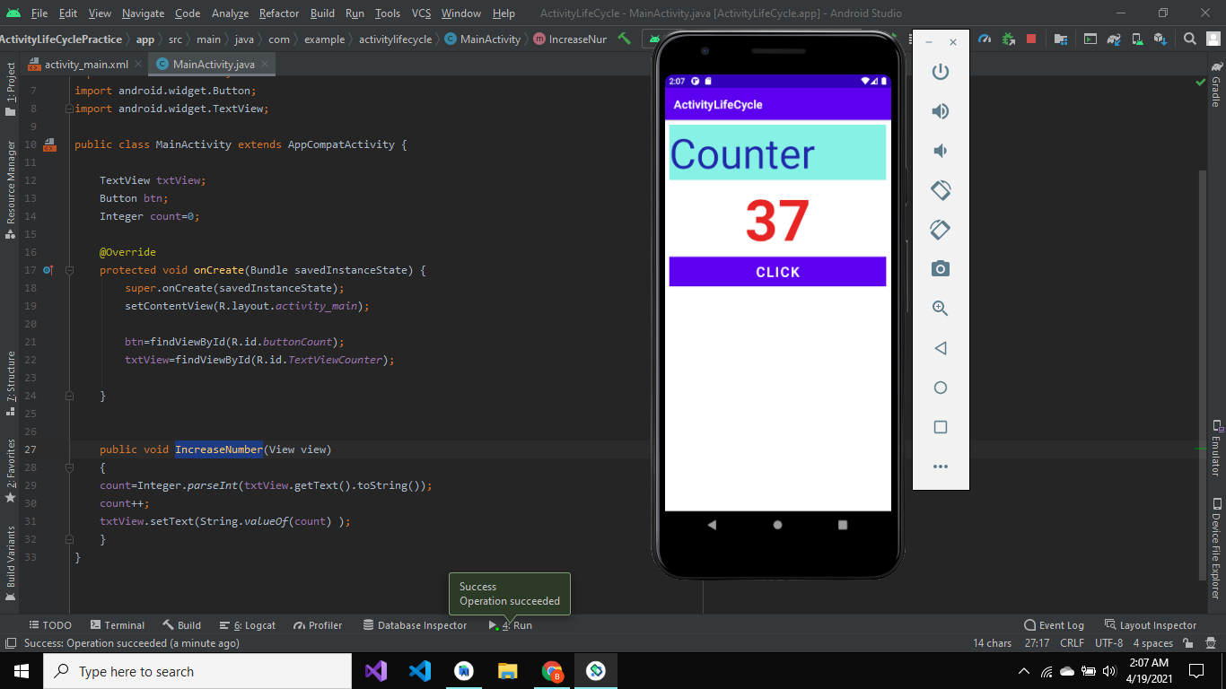

**Rotation-Action Problem:**

When we rotate the screen counter values goes back to zero

|  |  |
| --- | --- |
| **Before Rotation:** | **After Rotation:** |

* **Activity LifeCycle**
* **Create a LOG**

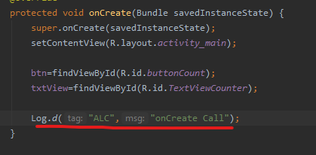

* **To Override methods:**

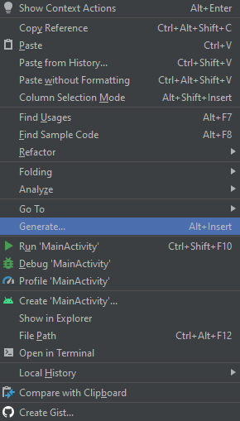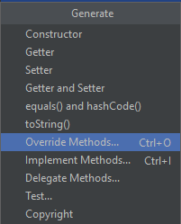

Override the 6 methods in main activity to check their logs in logcat.

* **onCreate()**
* **onStart()**
* **onResume()**
* **on pause()**
* **on Stop()**
* **onDestroy()**

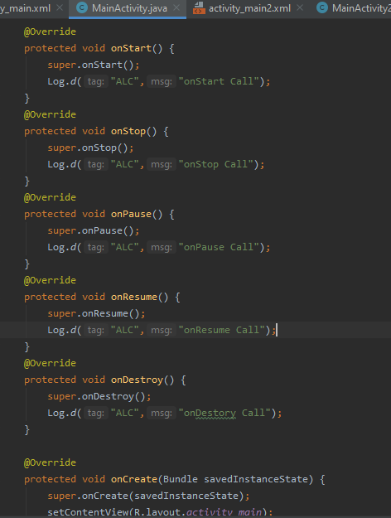

* **ALC of One Activity:**
* Run the emulator and check the logcat.
* On running the application following three funcion will be called as shown in logcat

1. onCreate()
2. onStart()
3. onResume()

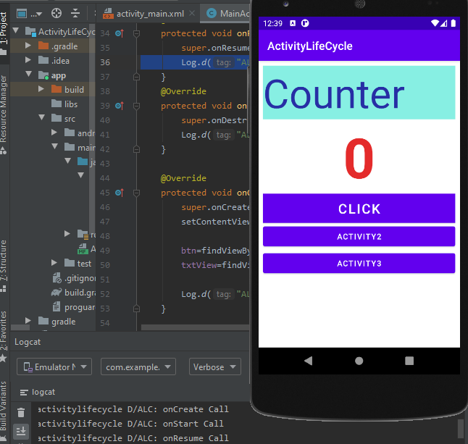

* On just clicking back button on emulator screen following three functions will be called.

1. on pause()
2. on Stop()
3. onDestroy()

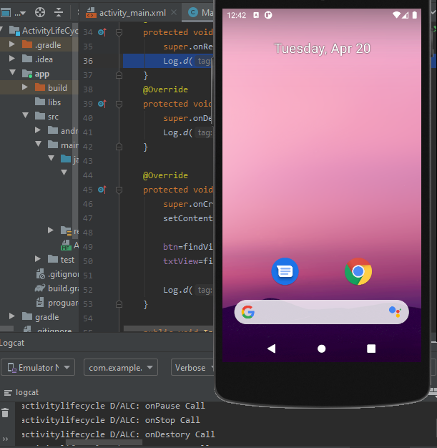

* **ALC of Main activity to any other activity:**
* Override the same 6 functions in activity2.
* Rebuild the application and this time after opening the main activity navigate to second activity and see the logcat.
* Logcat is displaying functions calls by tag names as:

ALC => for Main Activity

ALC2 => for second activity when clicked

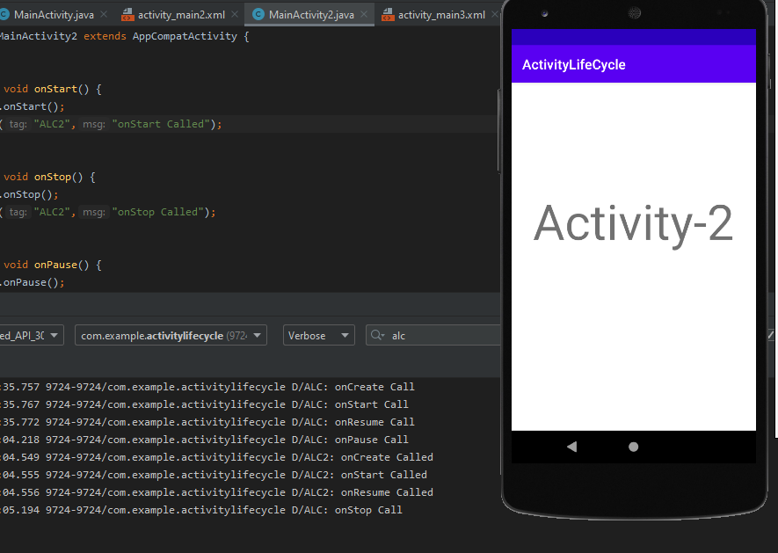

* Now from second activity click back to move back to main activity and see the logcat.

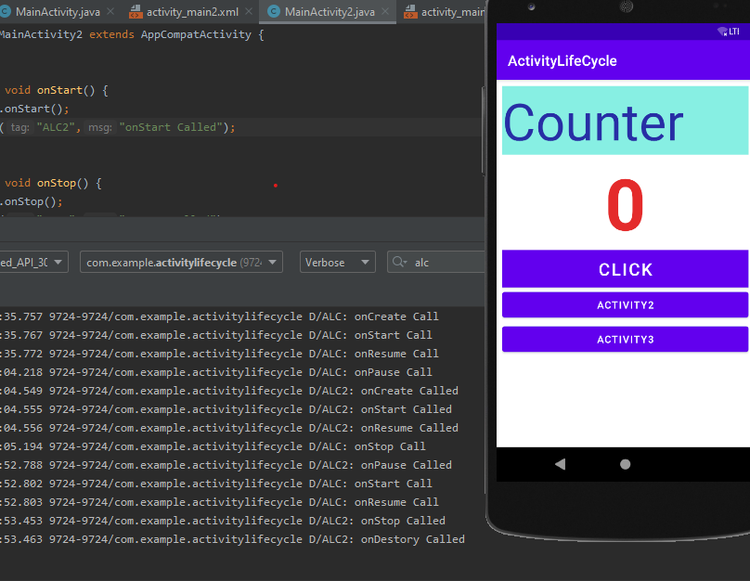

Repeating same steps for activity 3,navigate from main to 2nd activity then back to main and move to Activity-3. Then see the logcat.

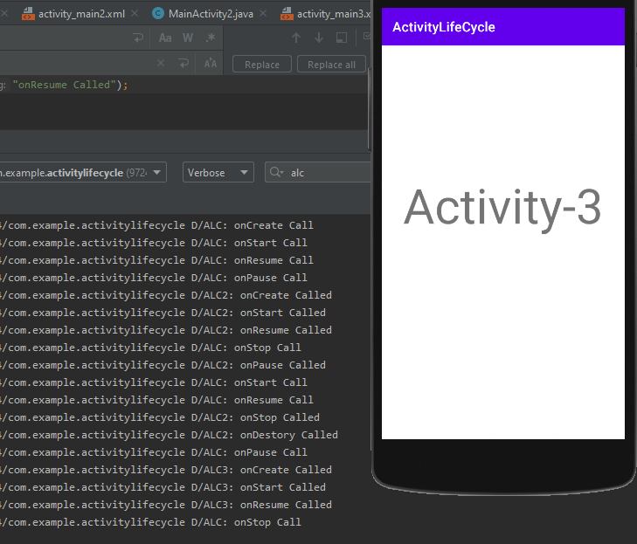

* **ALC of Main activity to other activity from other to another activity:**

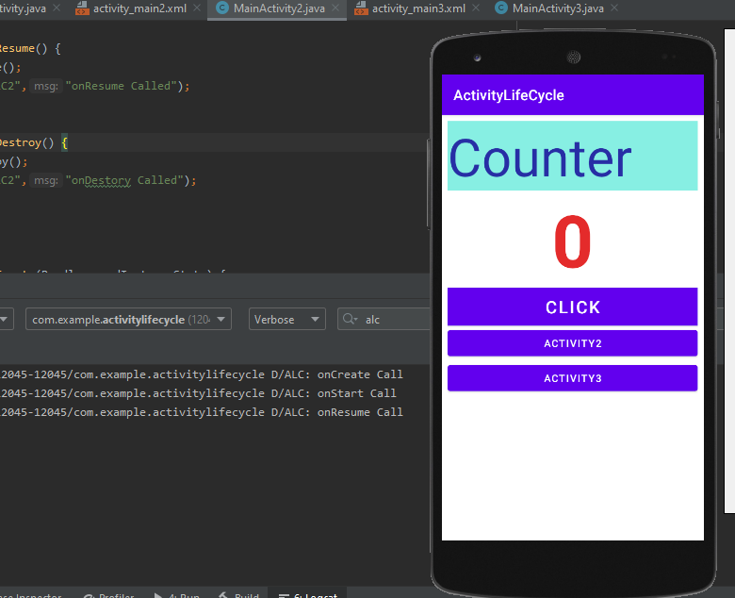

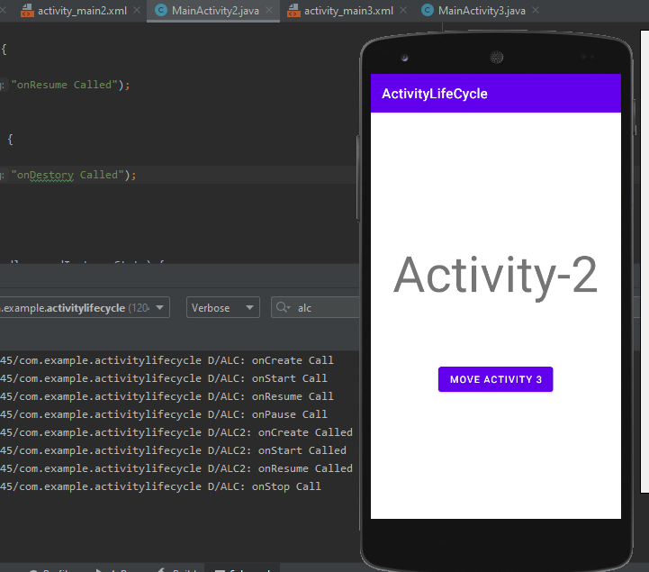

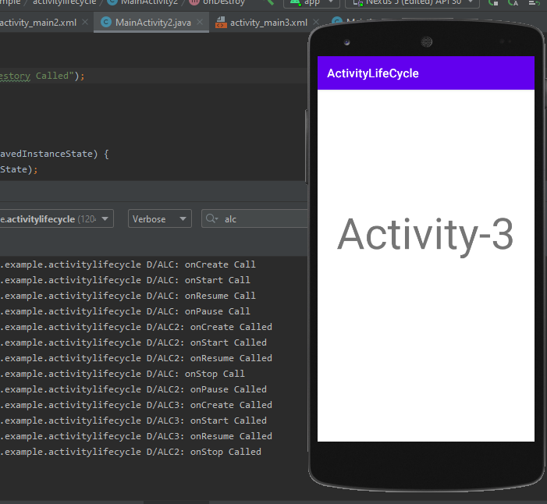

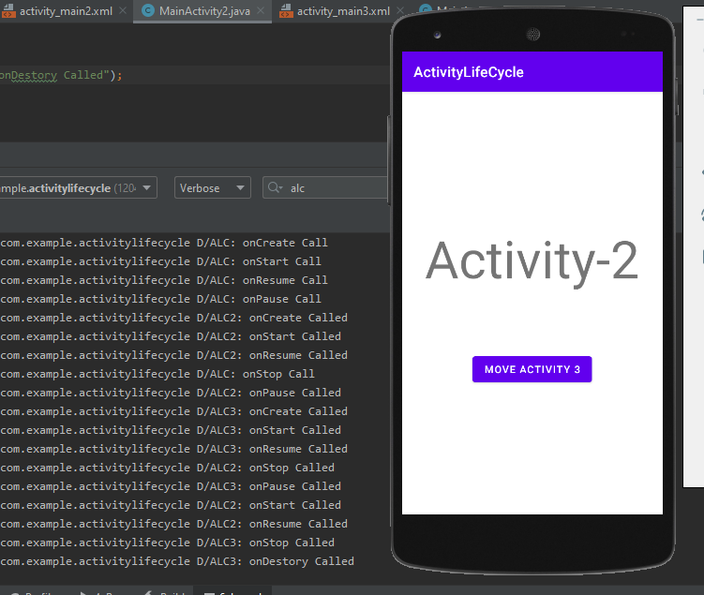

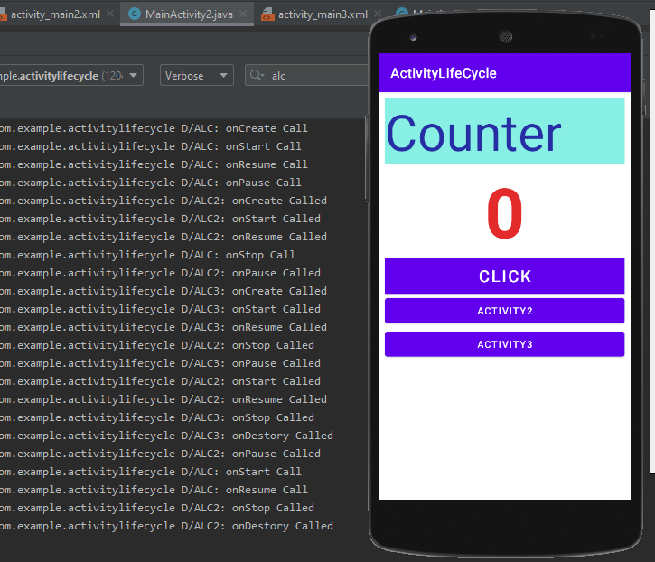

**Reason =>Rotation-Action Problem:**

* **On screen rotation onDestroy() is called so value of count doesn't get saved and after rotation activity starts again .**

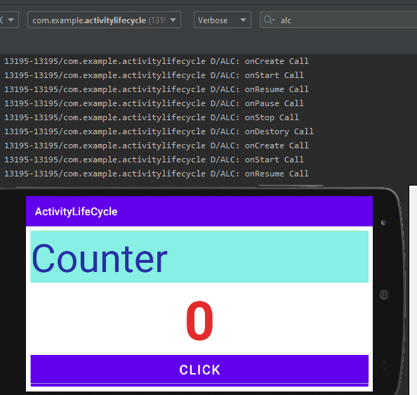

**Solution =>Rotation-Action Problem:**

* **Save values before destroy**

Add the following method in the activity and save value of count in the bundle.So that value of count can be stored before call of onDestory() and reused later on.

|  |
| --- |
| **@Override**  **protected void onSaveInstanceState(@NonNull Bundle outState) {**  **super.onSaveInstanceState(outState);**  **outState.putInt("value",count);**  **}** |

Put an if condition to check instance state and display value stored by bundle.

|  |
| --- |
| **protected void onCreate(Bundle savedInstanceState) {**  **super.onCreate(savedInstanceState);**  **setContentView(R.layout.*activity_main*);**  **if (savedInstanceState!=null)**  **{**  **count=savedInstanceState.getInt("value");**  **txtView.setText(String.*valueOf*(count) );**  **}**  **}** |

Now check the screen after rotation it will display the count exactly that was before rotation.

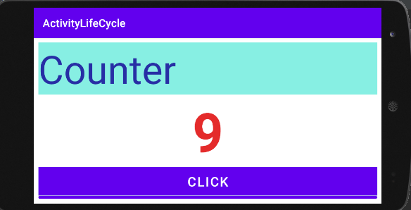

**Checking Counter on Activity Navigation:**

Now comment the display code in if condition.

|  |
| --- |
|  |

Run the emulator and see add come counts,then rotate and see behavoiur.

|  |  |
| --- | --- |
|  |  |

Now get back to original rotation format and then move to other activity.

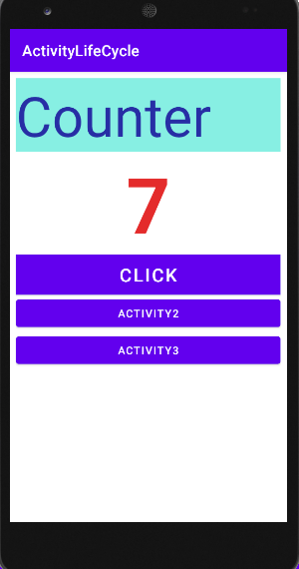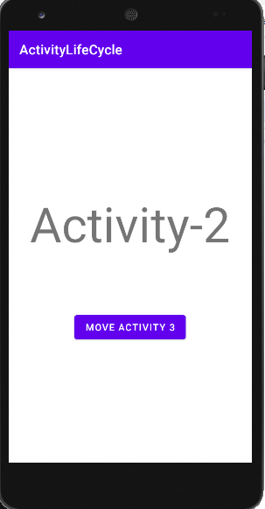

Move back from second activity and see the behaviour. The count value will be the same as you saved.

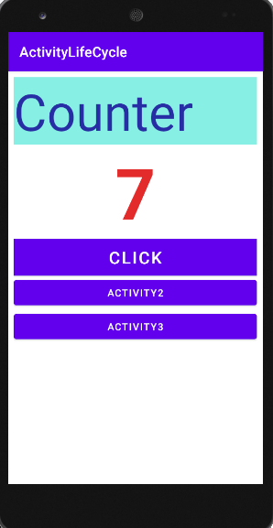

**LECTURE#8**

* **Android Adapter:**

In Android, Adapter is a bridge between UI component and data source that helps us to fill data in UI component. It holds the data and send the data to an Adapter view then view can takes the data from the adapter view and shows the data on different views like as ListView, GridView, Spinner etc.

* **List View:**
* Add a list view from pallet on xml page.

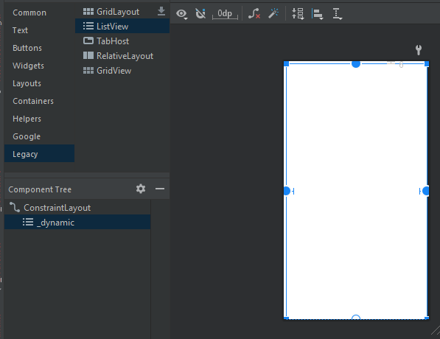

* Set Constraints.

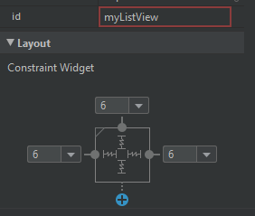

* **Array :**
* Make an array of strings, and display it using **array adapter.**

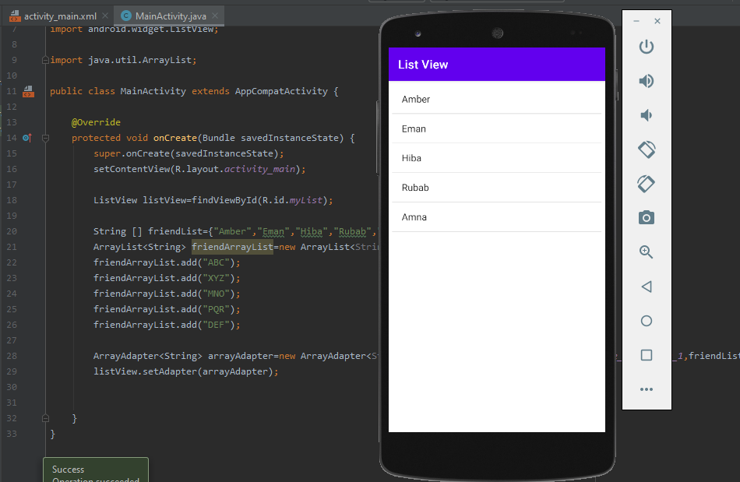

* **Array List:**

Make an ArrayList of strings, and display it using **array adapter.**

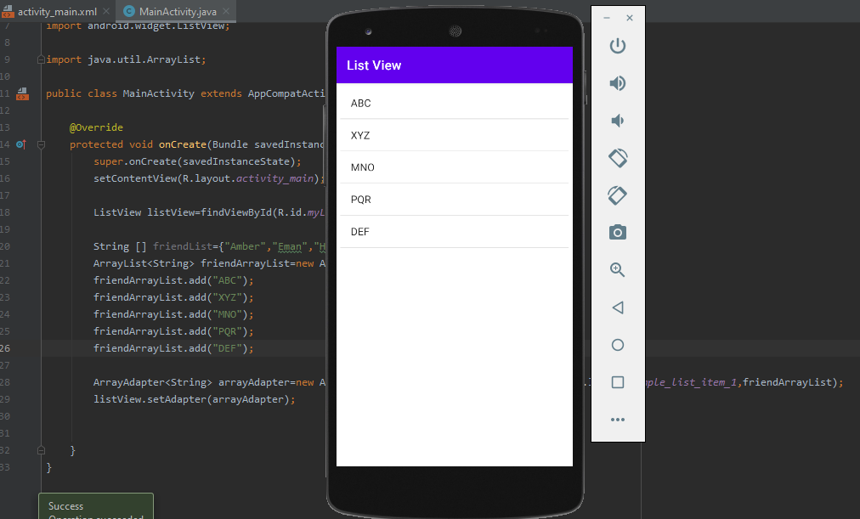

* **Add new Record**
* In the list view, Add a button and plain text.
* Then set their constraints in such a way that list is displayed under them.

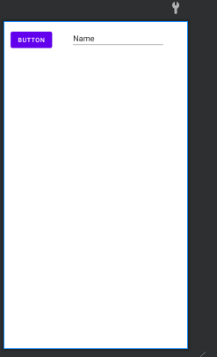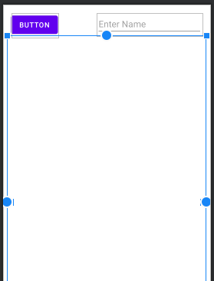

* The layout will be like the image below.

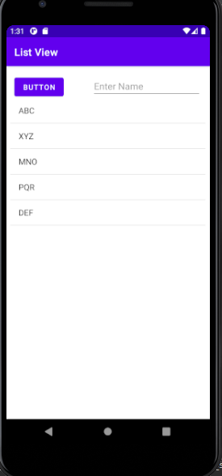

* On click event of listener add text to list using function.

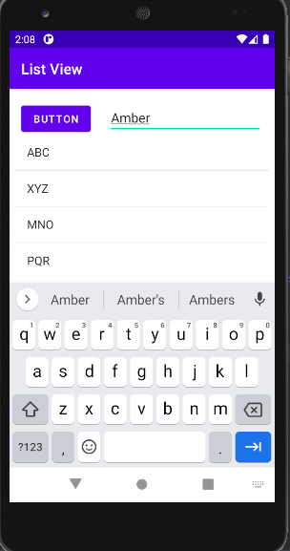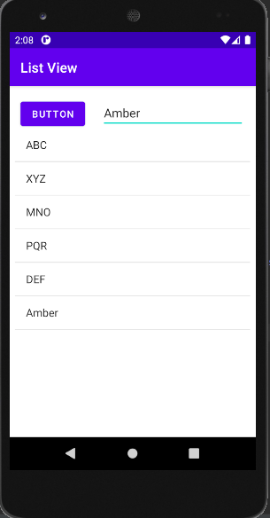

* **Log Checking List Items :**
* Check the clicked item in log using the log function in activity.java file.

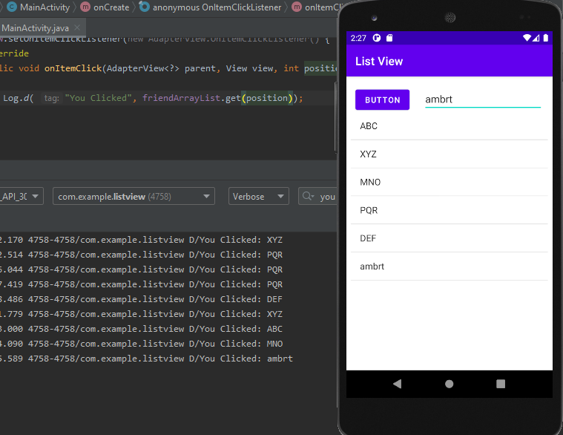

* **Sorting:**
* Array list items can be sorted using the functions as shown below.

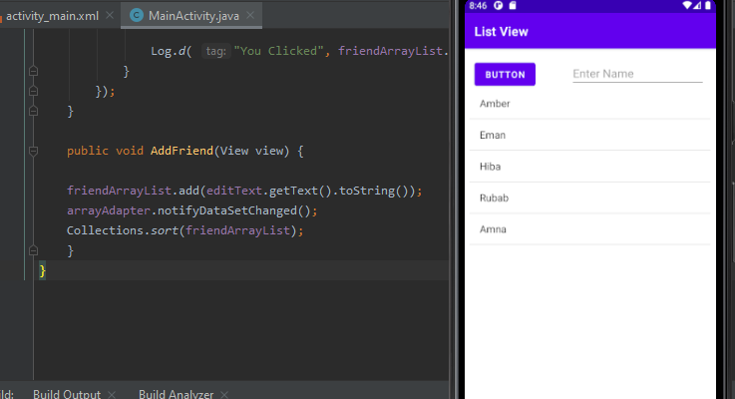

* After using the sort function add new items to list and check the their sorting accordingly.

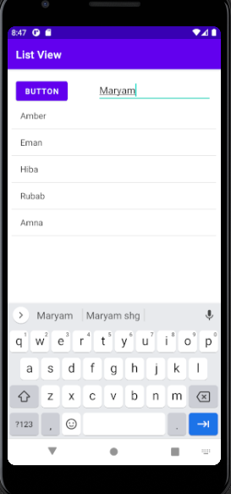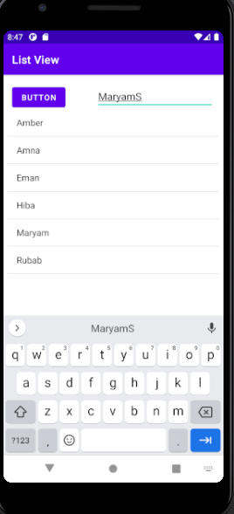

* **Add Hint in Text View:**
  + Instead of using some text add hint to text view to facilitate user to add thierown text while clicking on the view.

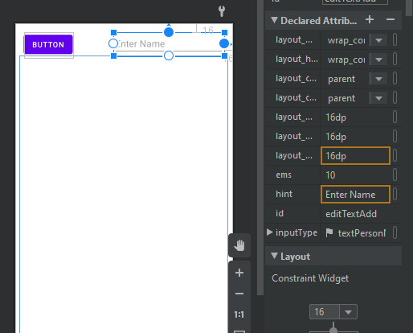

* **Pass Data from One Activity to Another:**
* To pass the data from one activity to another, add new activity and then add a text view in it.

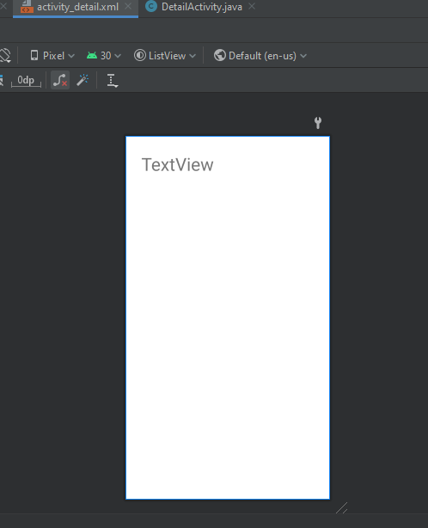

* Then make an intent as below to move from 1st activity to second.

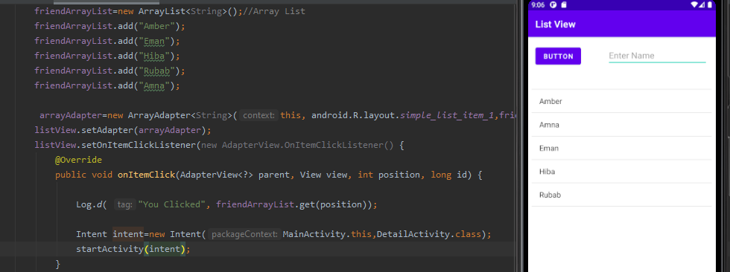

* Check the activity navigation on emulator.

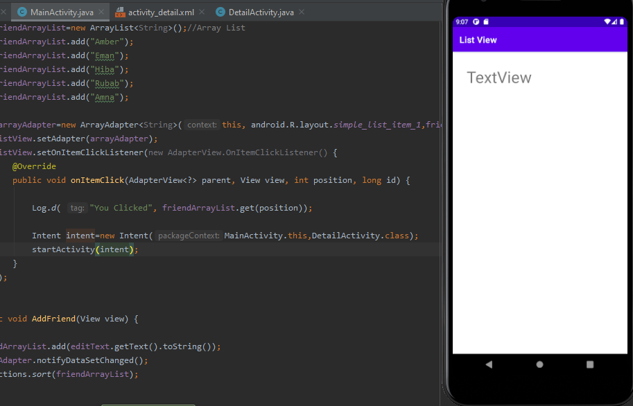

* Now set the clicked item of list of first activity as text of second activity.

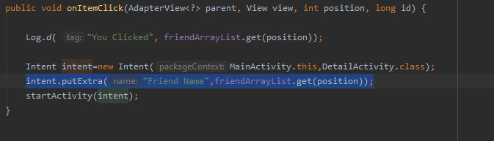

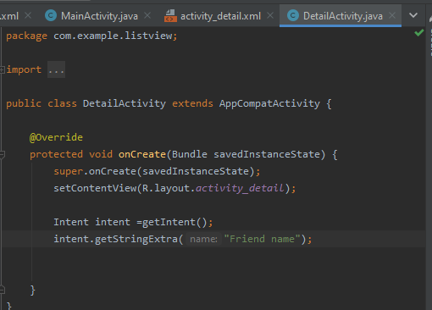

* Place a log function to see the clicked items in one activity and checked in second activity.

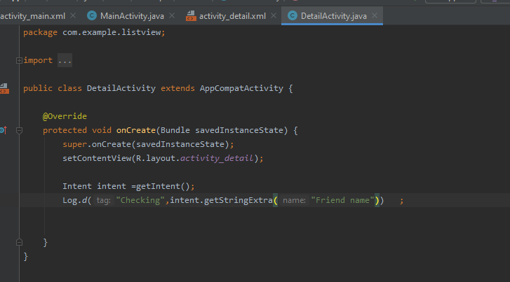

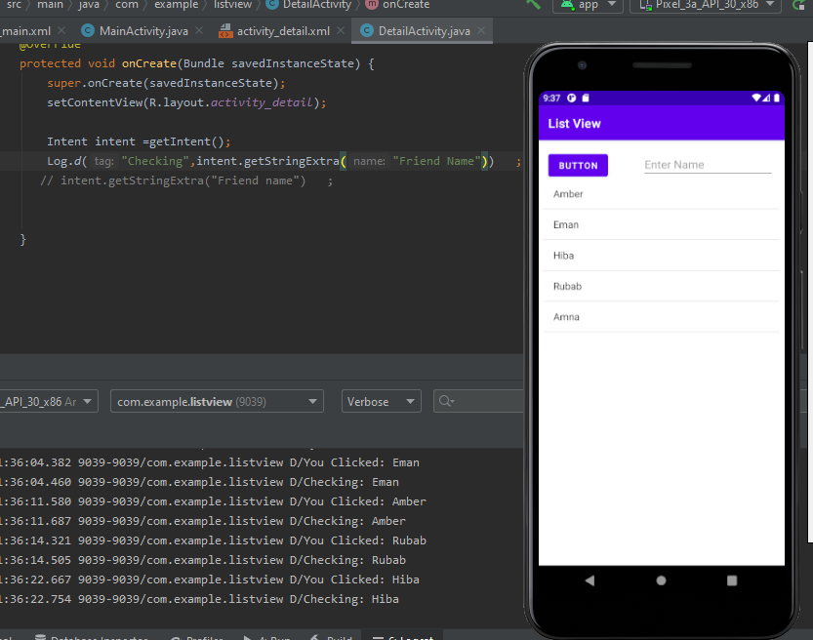

* Get the clicked item in second activity to display when clicked.

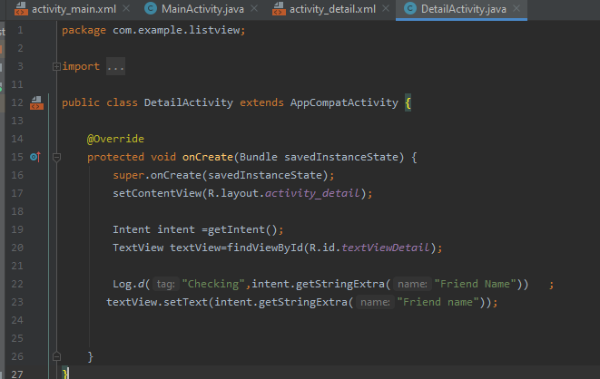

* Now see the output on emulator, as we click any item in activity one it will be displayed in second activity.

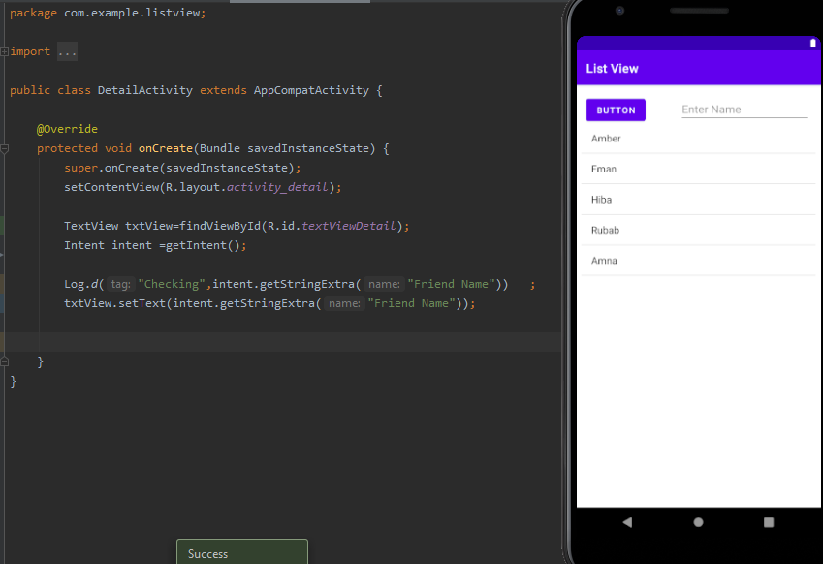

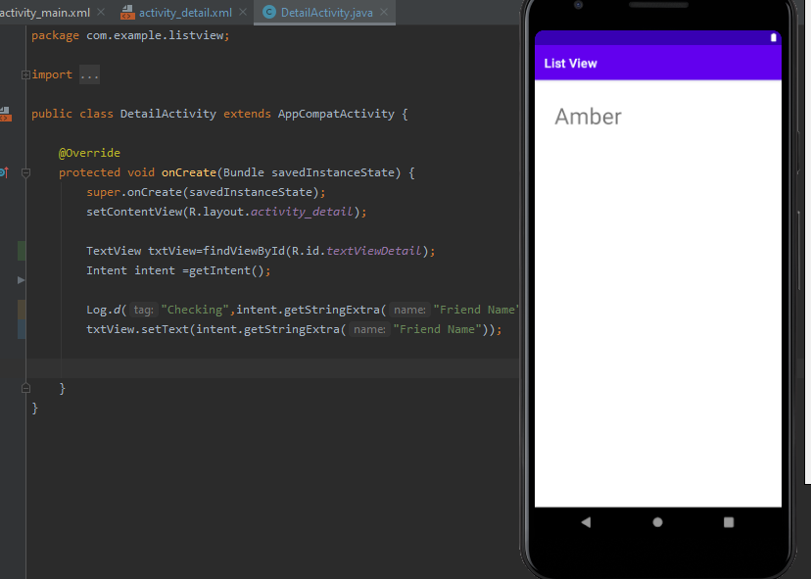

**LECTURE#9**

* **Seek bar:**
* Add seek bar from widgets on xml file.

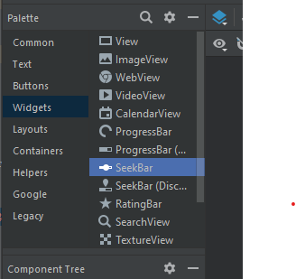

* Set constraints of seek bar**.**

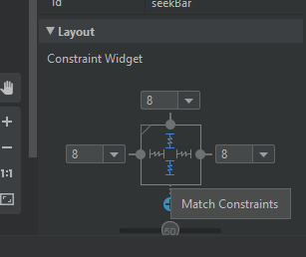

* After setting the position of seek bar , run it ti see its view on emulator.

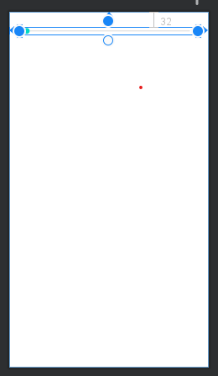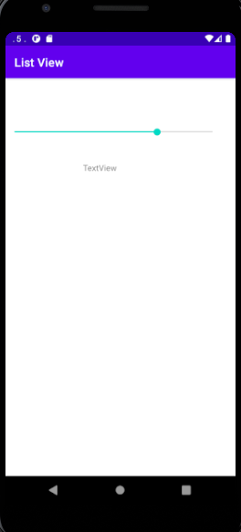

* **Setting Max value and read it in log:**
* Set maximum value of seek bar using function as below and check its output values by using log.
* As we run the emulator and move the seek bar the values will be displayed in log accordingly.

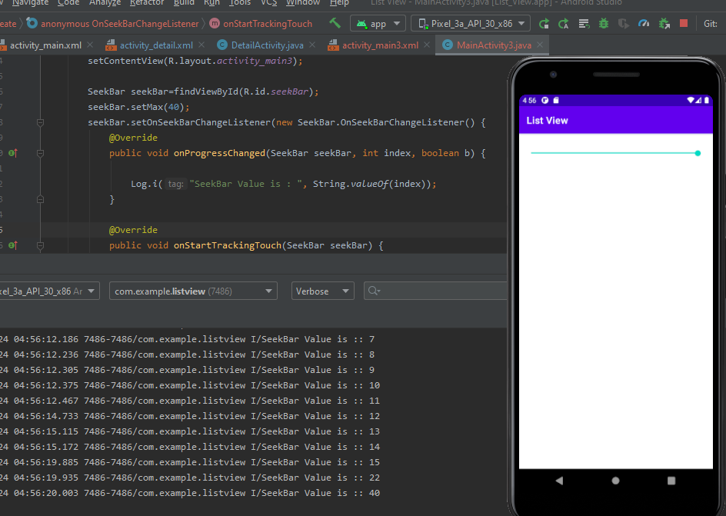

* **To print table of number on seekbar:**
* Use seek bar function to get its value and store it in table.

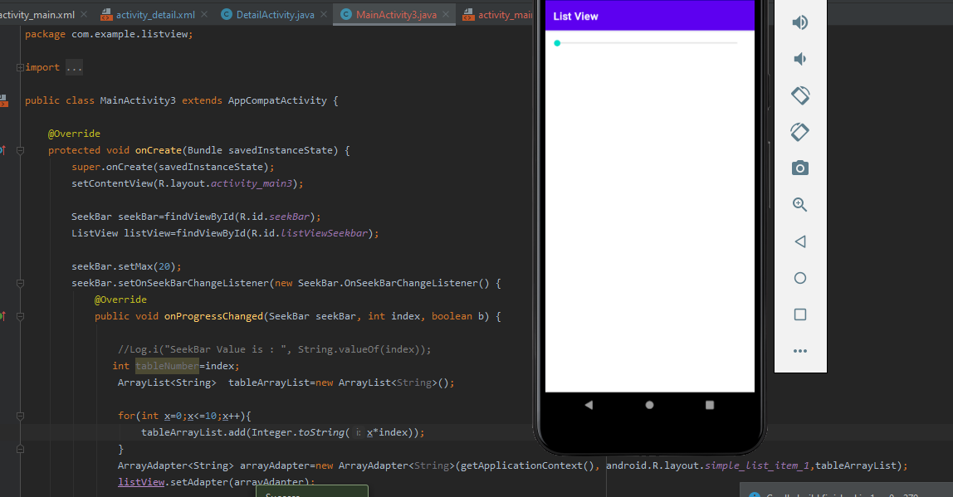

* Add a list view under seek bar in xml file .
* Write a function to display the table of value selected on seek bar.
* Run the emulator to see the output on screen.

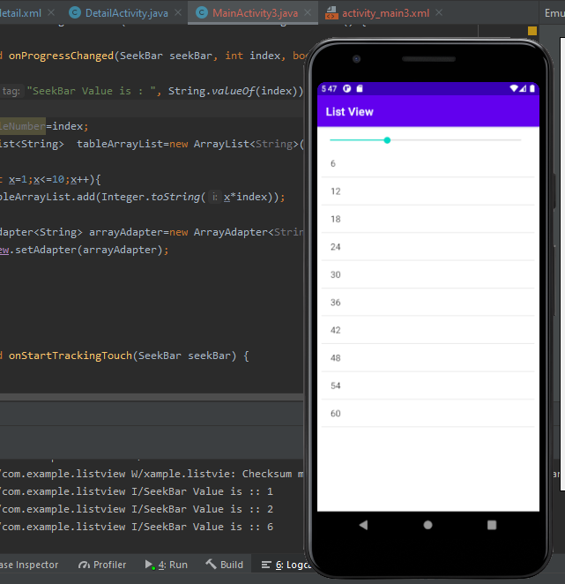

* **Widgets and Animations:**
* Copy come images from your PC and paste then in **drawable** folder in your project.

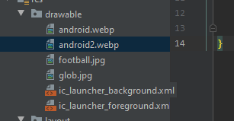

* Add an image view on xml file and select any image you want to add.

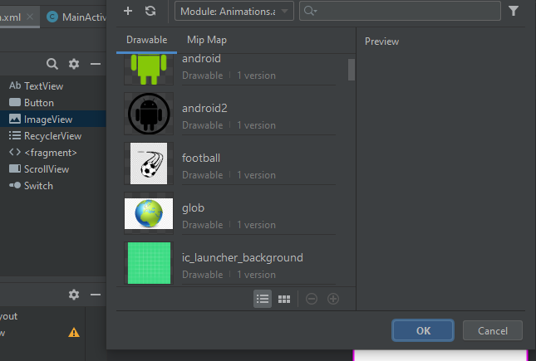

* Set image constraints and position.
* Run the emulator to see the output of image.

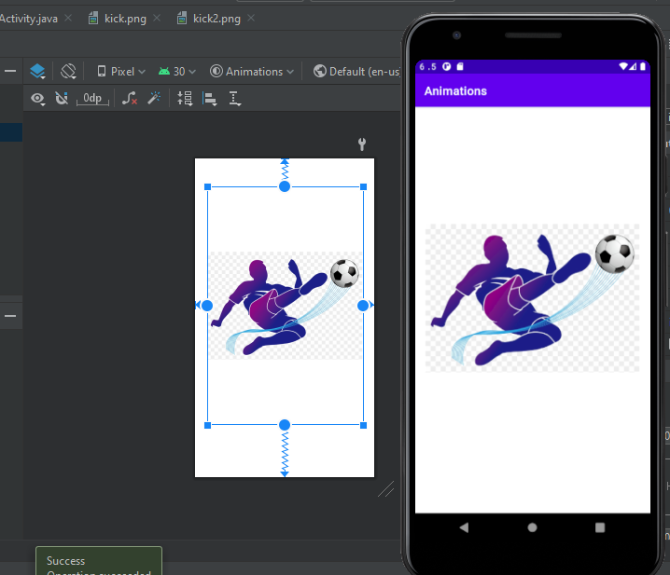

* **On click for image:**
* Write an onclick function for image to perform actions on image click.

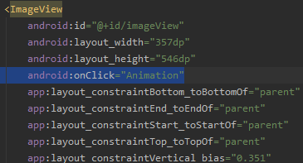

**Basic functions of Animation:**

* **Image Disappear Animation :**
* Write the function as below to get the disappearing effect on image click.

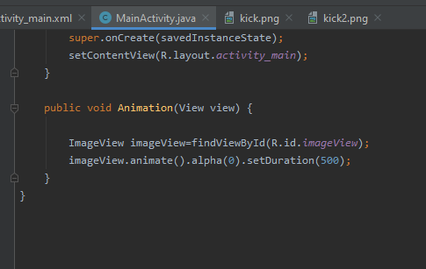

* Image view before click.

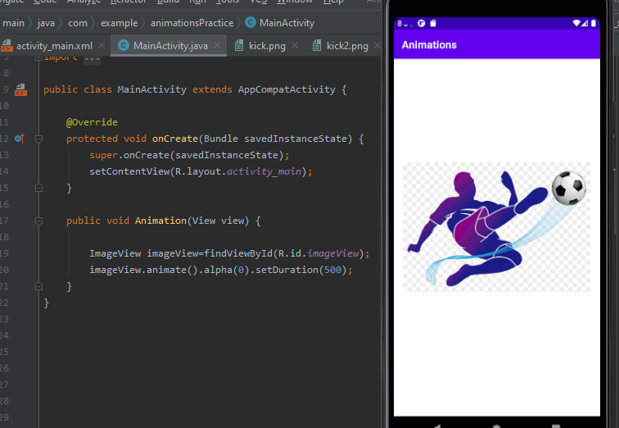

* Image disappeared just after click.

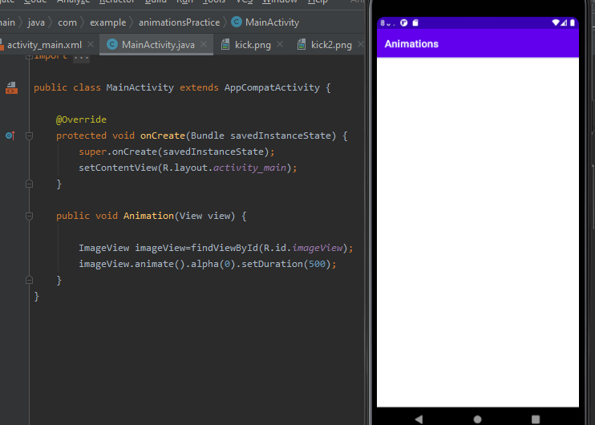

* **Image TranslationY Animation:**
* Write the function as below to get Translation along Y effect on image click.

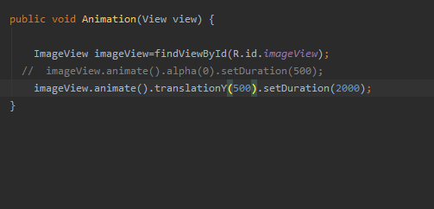

* Image moved along Y axis just after click.

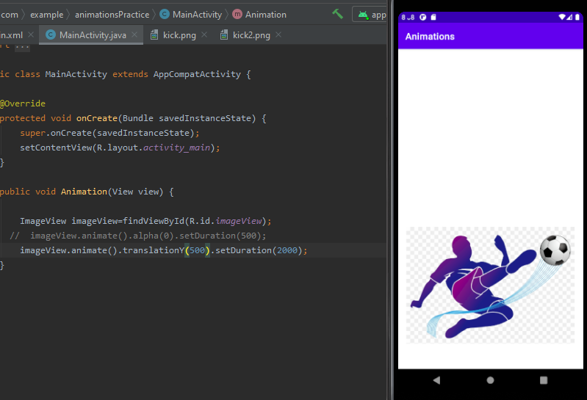

* **Image TranslationX Animation:**
* Write the function as below to get Translation along X effect on image click.

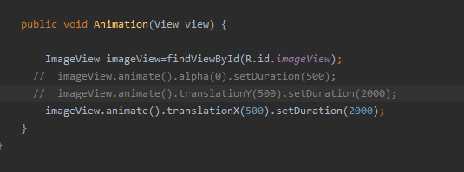

* Image moved along X axis just after click.

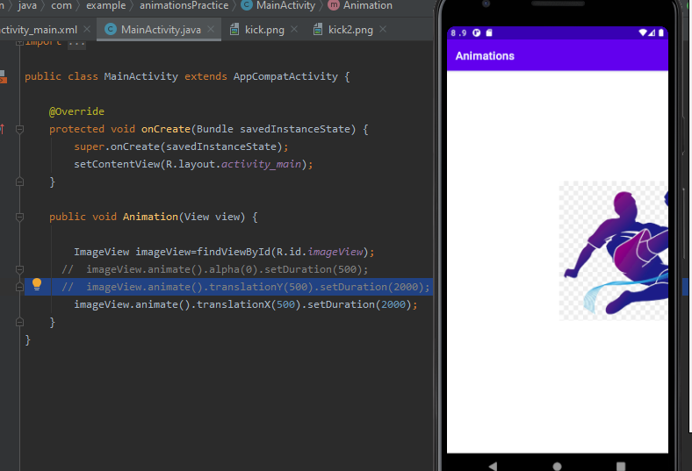

* **Image -Ve Translation Animation:**

Negative value => move to opposite side

* Write the function as below to get-Ve Translation Animation effect on image click.
* Image moved along opposite to X axis just after click.

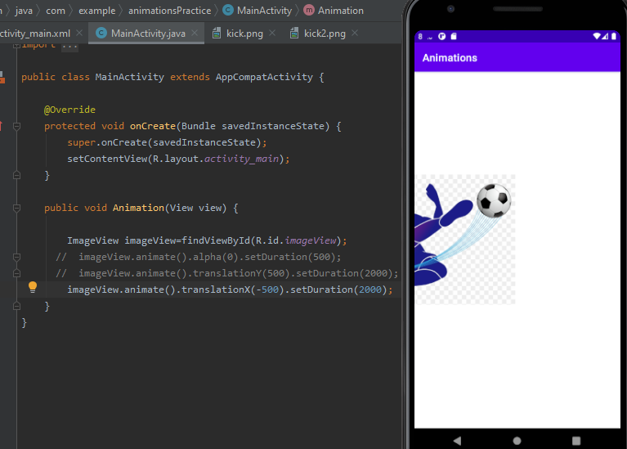

* **Image Rotation Animation:**
* Write the function as below to get rotation effect on image click.

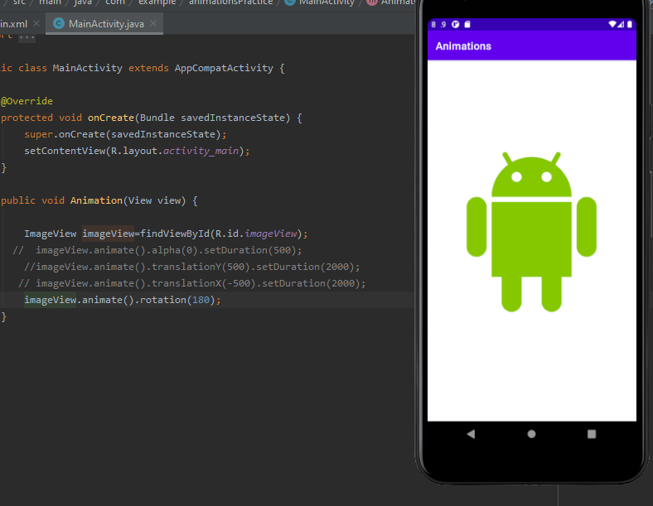

* Image rotated to 180 degree just after click.

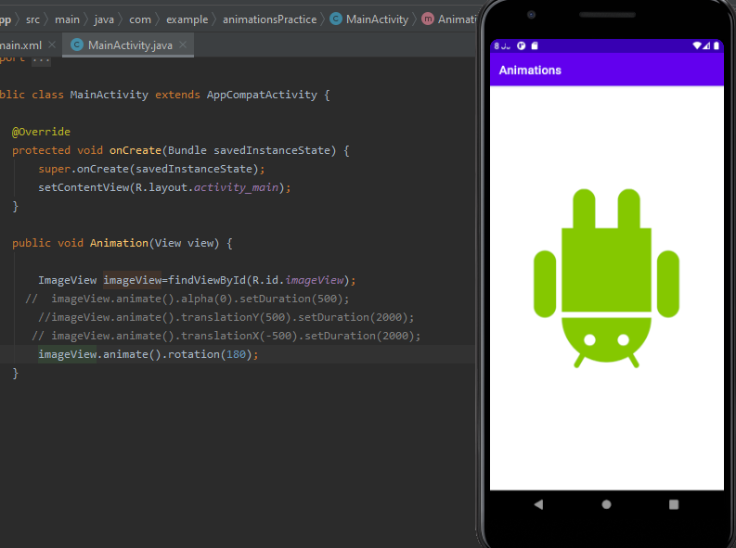

**For Double Rotations:**

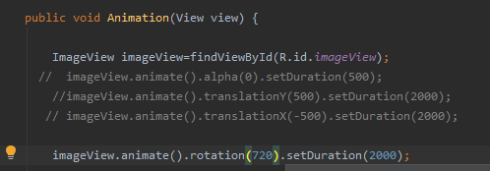

* **Image Rotation,Disappear and Duration at same time:**
* Write the function as below to get rotation, disappear effect with some duration on image click.
* Image rotated and disappeared in given duration.

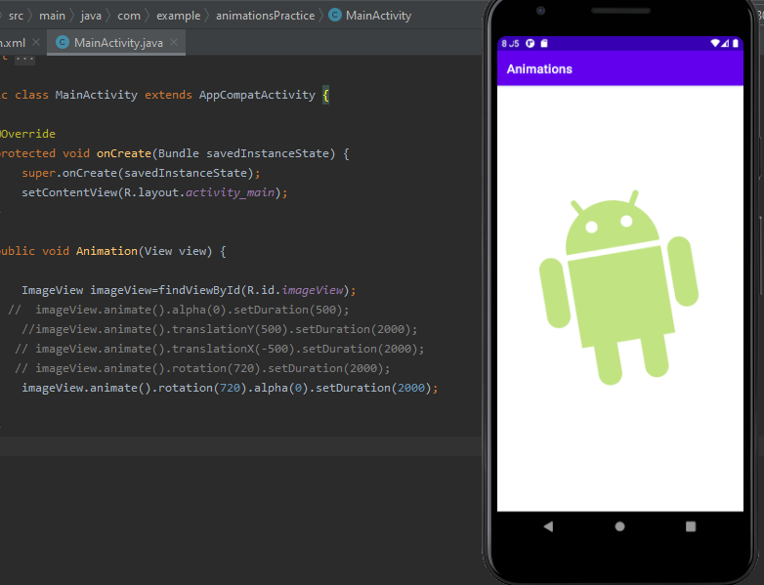

* **Share to GitHub Using Android IDE:**

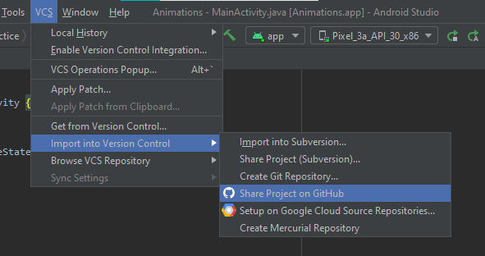

* **Image Scaling Animation:**
* Write the function as below to get scaling effect on image click.
* Image scaled to x-axis just after click.

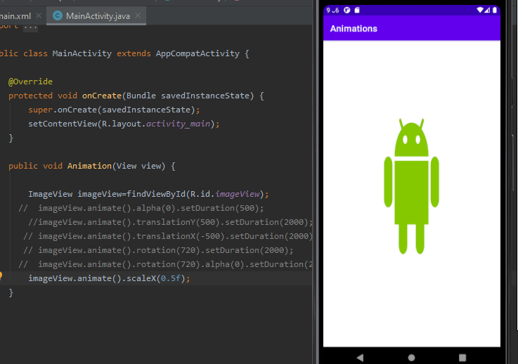

* Image scaled to y-axis just after click.

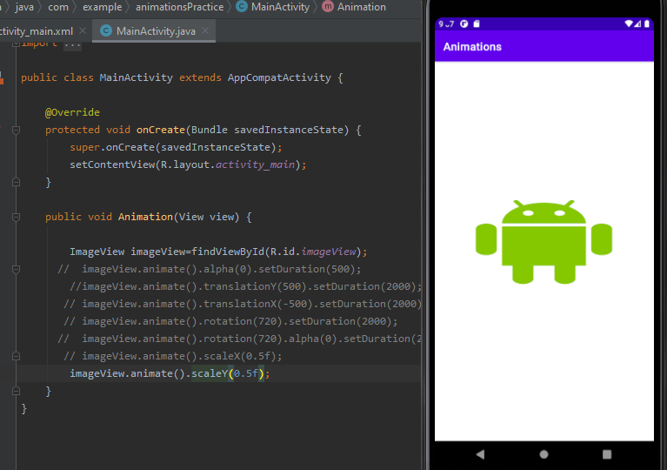

* **Image Scaling ALong Both XY axis:**
* Write the function as below to get scaling effect on image click.

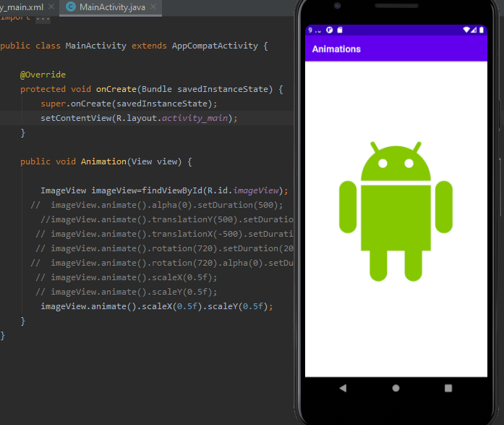

* Image scaled to both xy-axis just after click so squeezed.

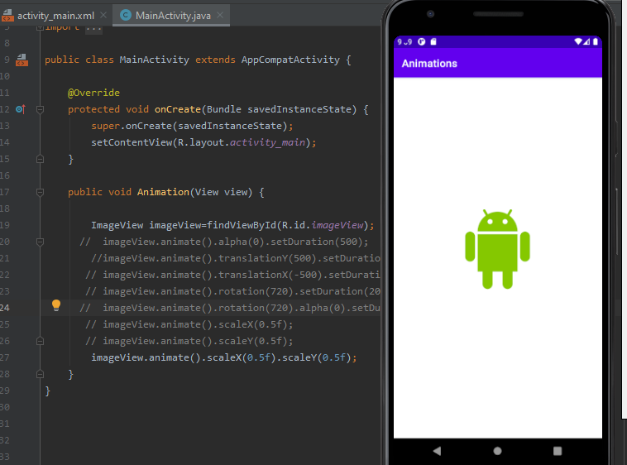

* **Image Scaling + Rotation at same time:**
* Write the function as below to get scaling and rotation effect on image click.
* Image rotated and scaled to both xy-axis just after click.

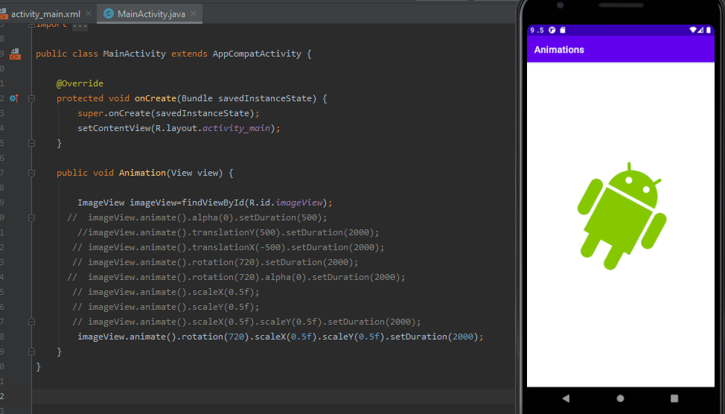

* **Videos:**
* Create a new activity and set it as launching activity.

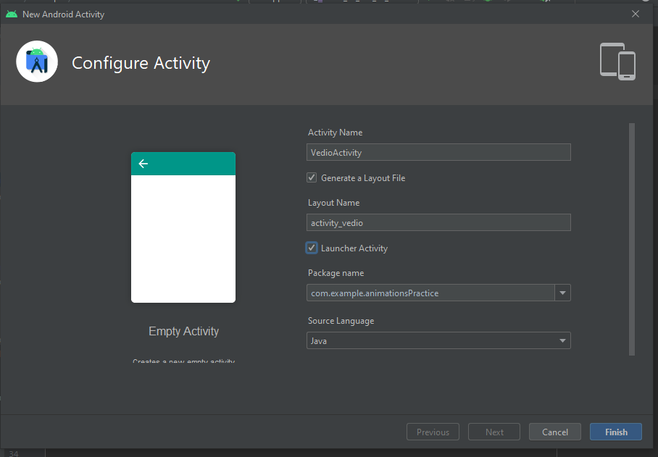

* Add an video view from widgets.

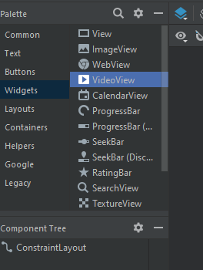

* Set the constraints of view and fix its position.

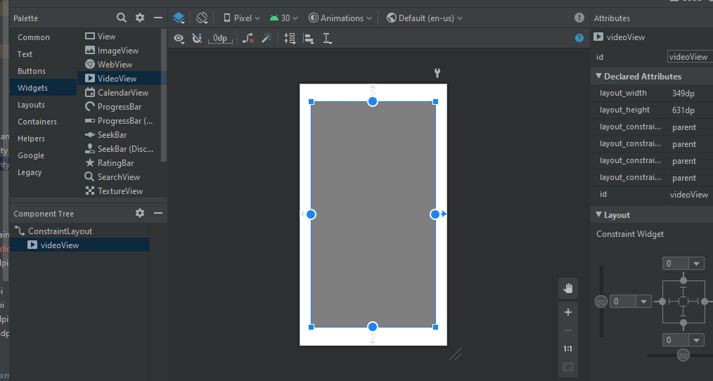

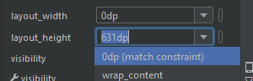

* In **res** folder make a folder named **raw.** Then copy videos you want to add from PC and paste in this folder.

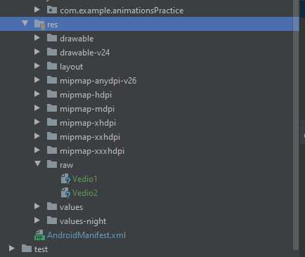

* Add the code below to make a video view on screen. Run it and see the video output on emulator.

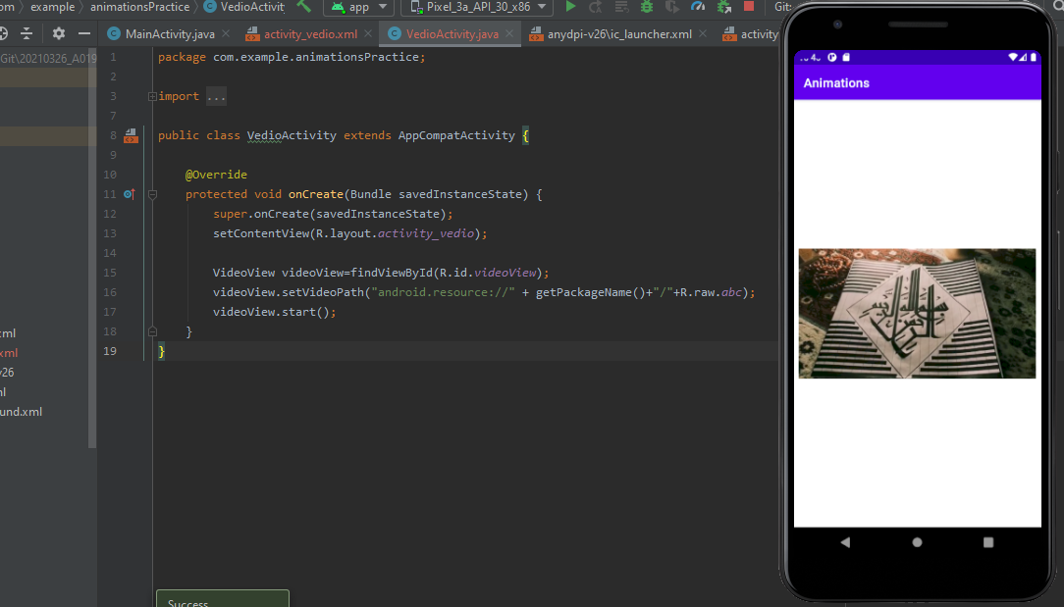

* **Set Video Controls:**
* To set video controls add the code below.

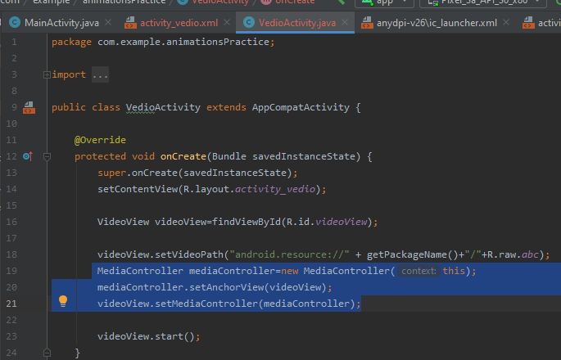

* Run it and see the output on emulator, the video with controls.

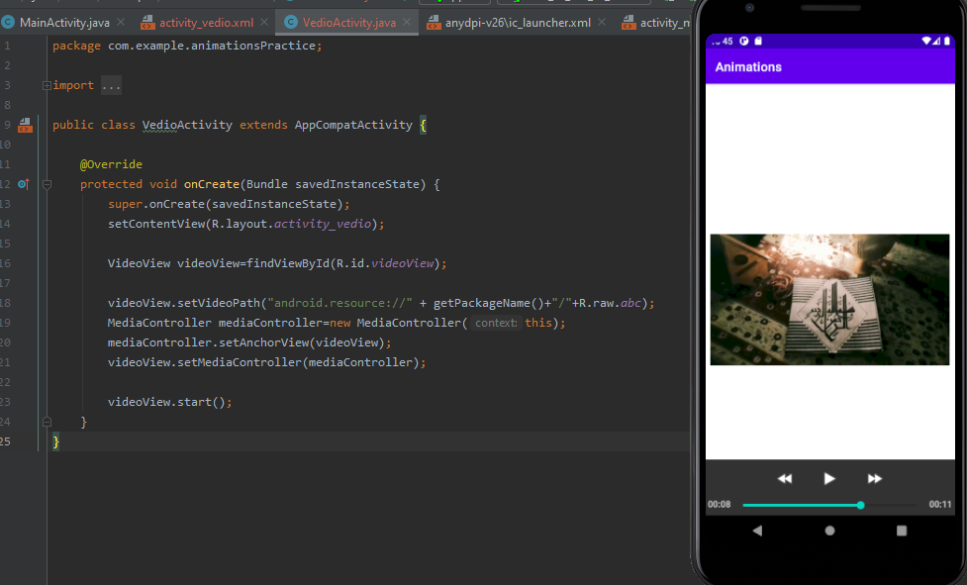

* **Audio Files:**
* Create a new activity and set it as launching activity.

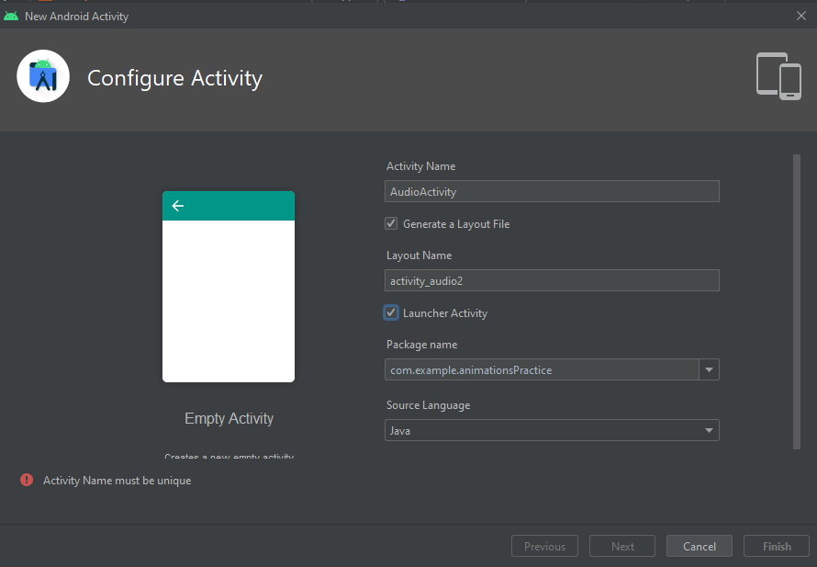

* In **res** folder make a folder named **raw.** Then copy audios you want to add from PC and paste in this folder.

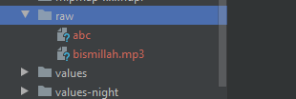

* **Set Audio Controls:**

Android don't have built in functionality so wee need to add buttons to set audio controls.

* Add 2 Buttons on xml file and set their constraints with position.

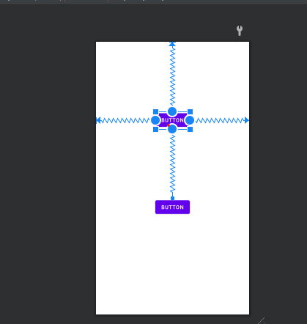

* Now write click event for one button as Play and other button as Pause.

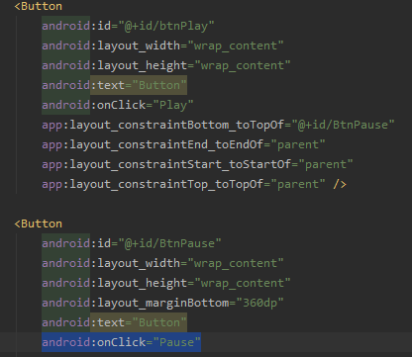**.**

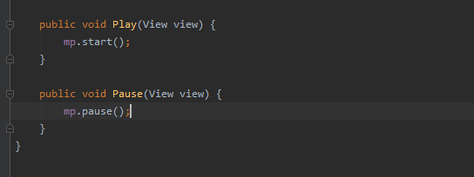

* Write the code to add audio on screen and set controls in functions on clicked by buttons.
* Run the file and see output on emulator. Play button will play the audio and pause will stop the audio.

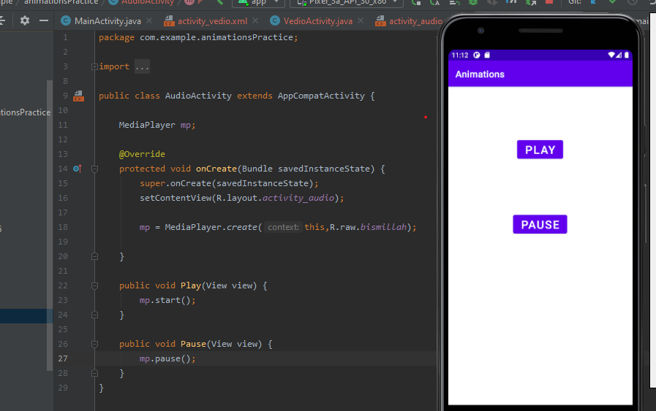

* **Uploading the Project on GitHub Repository:**

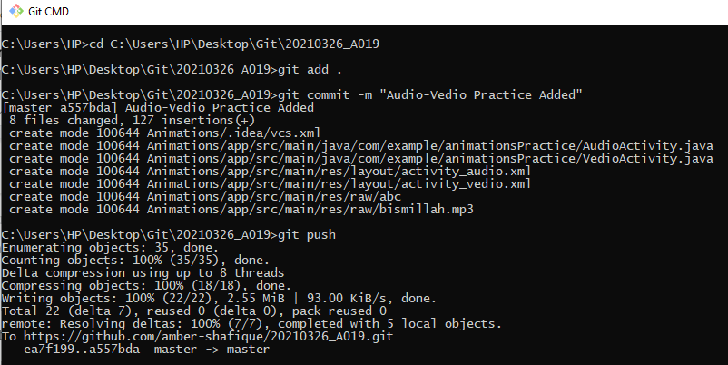

**LECTURE#10**

* **SQlite-Lec1:**

**To make a view for entering and retrieving data from database:**

* Add a plain text field and set its constraints.

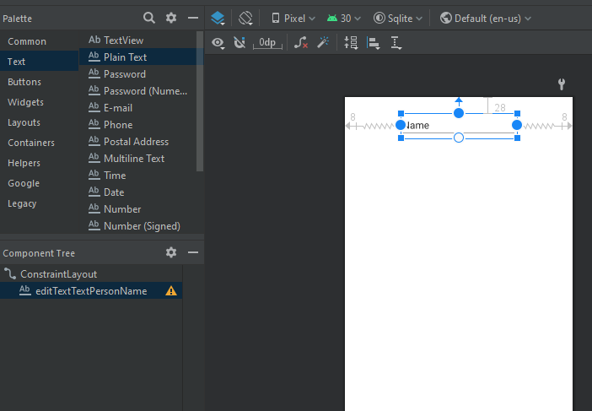

* **Add new string resource:**

To save the id of the text field create a new string resource.

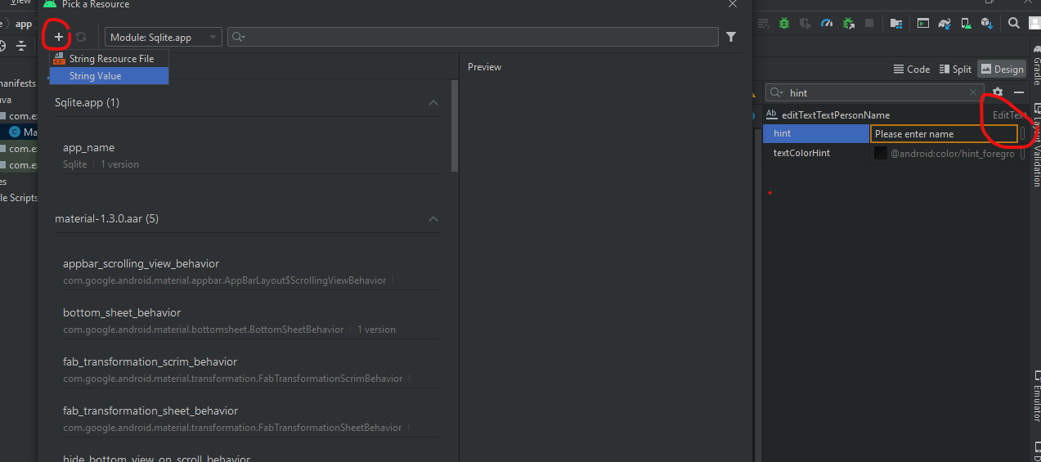

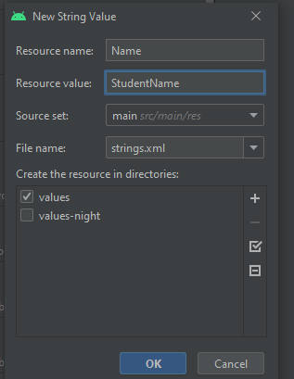

* Add another field of number & set its constraints too.Also add new string resource for it.

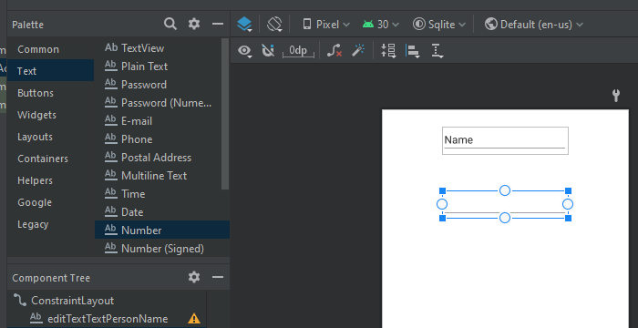

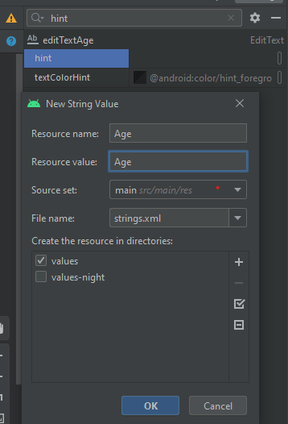

* **Viewing String Resources:**

In resources=> values, string.xml file will be saving string resources.

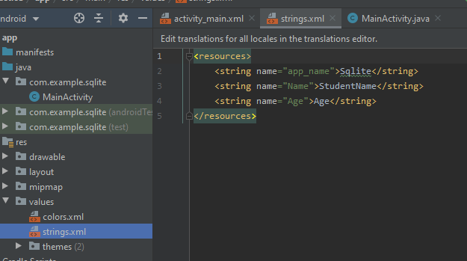

Set the default text for these strings and save.

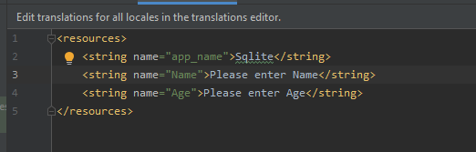

* After adding default text for strings run the emulator and see the output on screen.

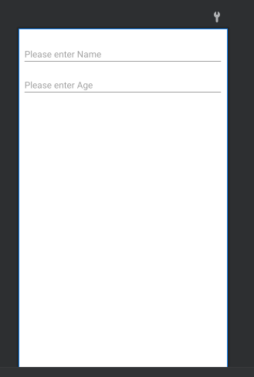

* Now add another field of switch on screen from the pallet.

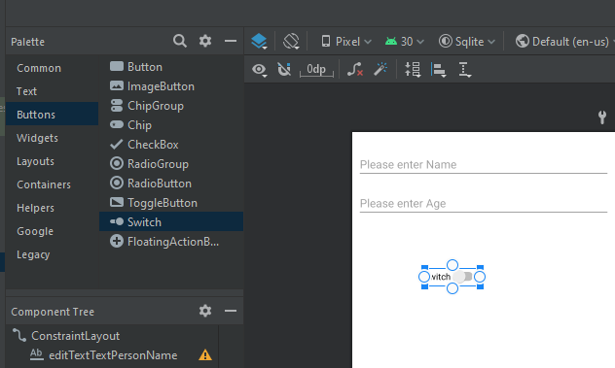

* Add a string resource for switch also.

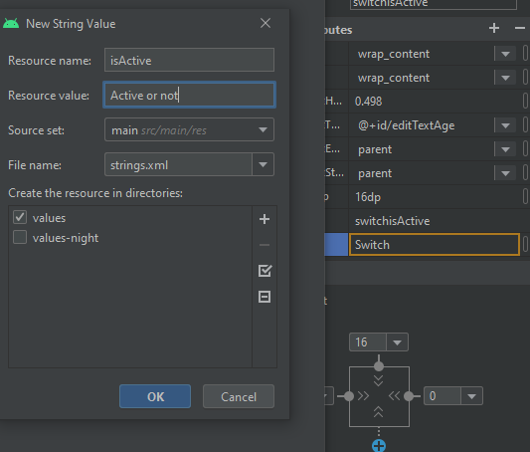

* Now add two buttons on the screen and set their constraints.

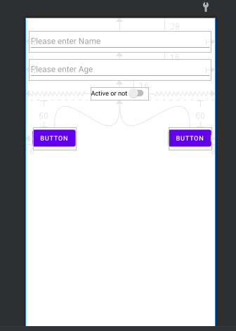

* Add a list view and set its constraints with buttons.

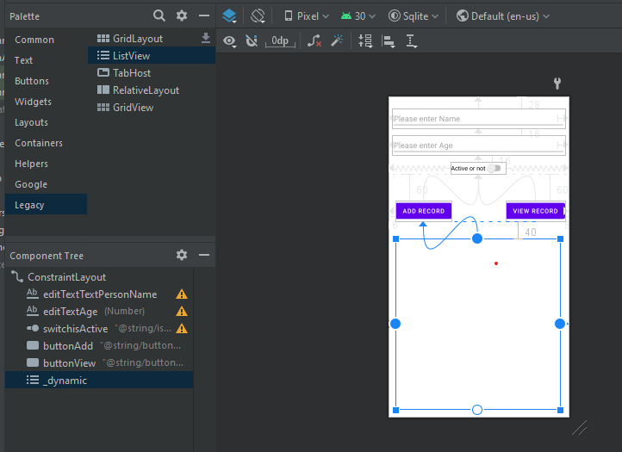

* Now run the emulator to see the whole srcreen view.

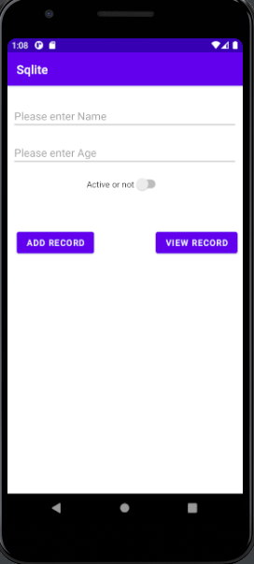

* **Using toast instead of log:**

To see the click events happening on screen add toast function instead of log.

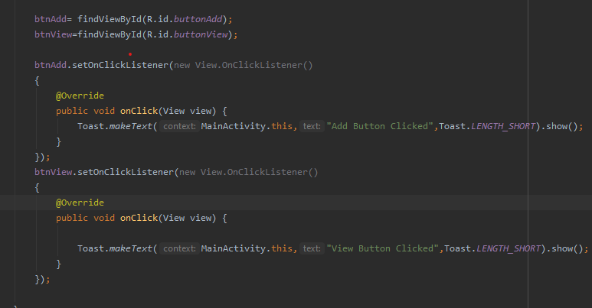

* After adding toast on click events of button run the emulator to see output.
* Just when you click the button the toast function will display a text notification in the bottom to let us know that which button is being clicked.

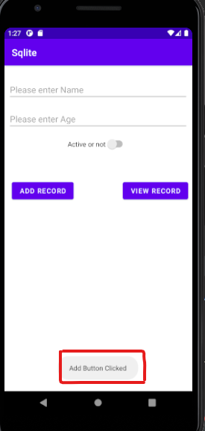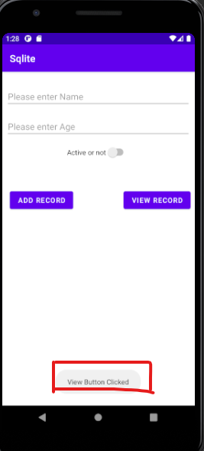

* **SQlite-Lec2:**

* **Retrieving Values from the model:**
  + Add a new Java class named as customerModel.

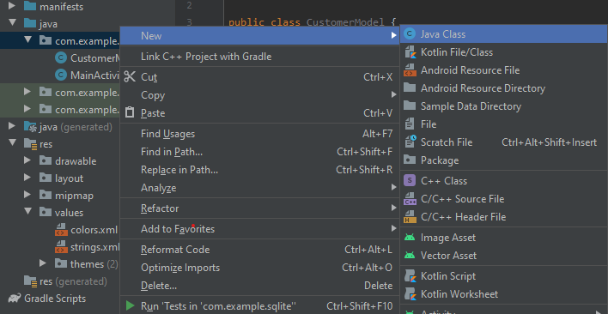

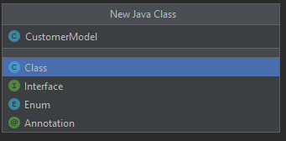

* **Adding Constructor:**
* After making a new java class add constructor using following steps.

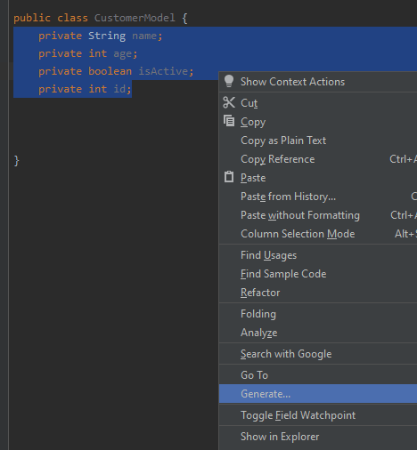

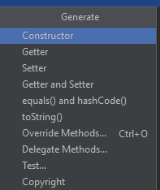

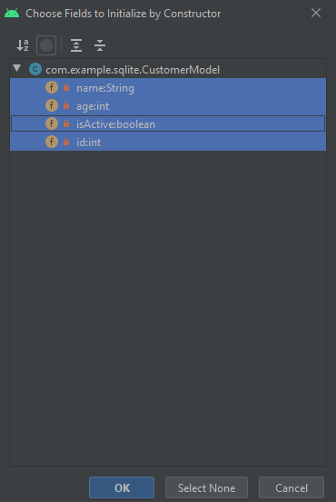

* After following above steps, following is the constructor that has been added to the class.

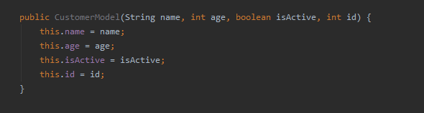

* **Adding Getter Setter:**
* To add getter setter in tha java class following are the steps to follow.

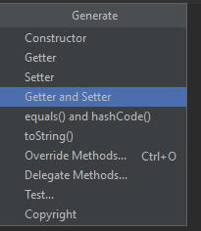

* After following the above steps, following is the view of getter setters that have been added to java class.

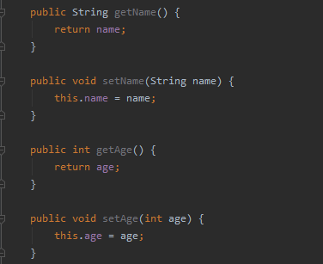

**Override toString method:**

Now override the toString() method in class using following steps.

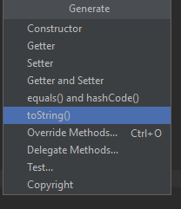

* After following the above steps, following is the view of toString() method that have been added to java class.

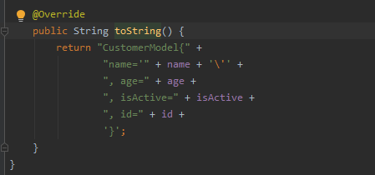

* **Adding class object in main activity:**
* Add instance of the above class in main activity so we can get its values.

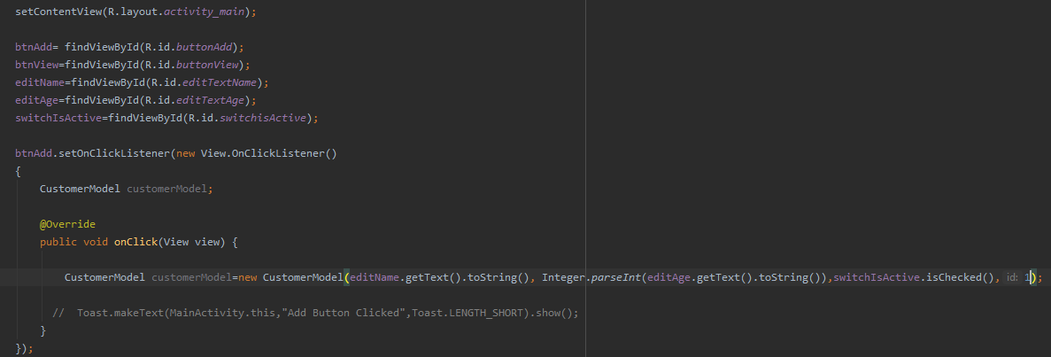

* **Add new toast to see data added:**
* Now to see the data added on click of button we add a new toast to get string values that have been passed to customer’s object.



* Run the emulator to see the data added on click of add record button.
* As we enter the data in text fields and click the add button, we will get its values represented in bottom of screen that are displayed by toast.

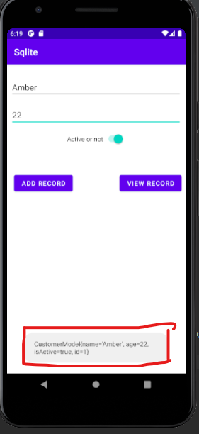

**To Open Created Database:**

* **To view files of the device:**
* Run the emulator first, and then follow the steps bellow.

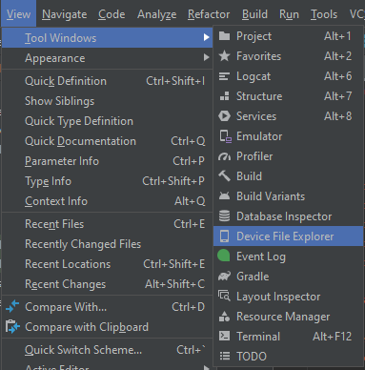

* Here in **data folder** are all applications that are available that we run on the emulator.

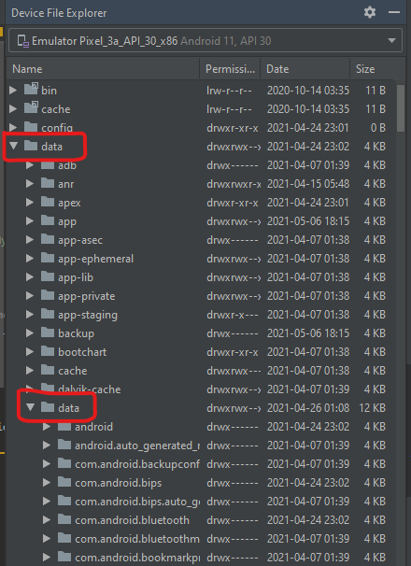

* **To View Database file:**
* To see the database file open the project’s package and click on its database as named in the DB helper class.

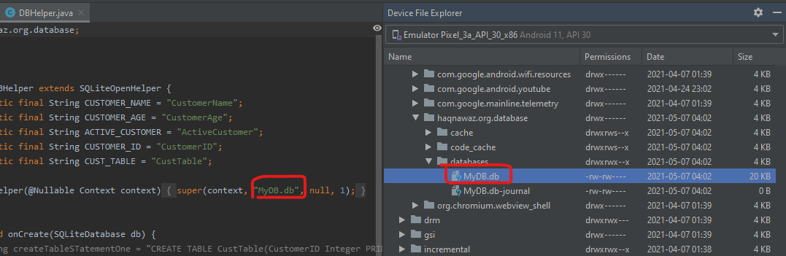

* Export the database on your system using save as.

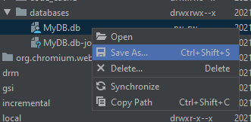

* Select a location to save your database, so you can view it later on in **SQLite Browser.**

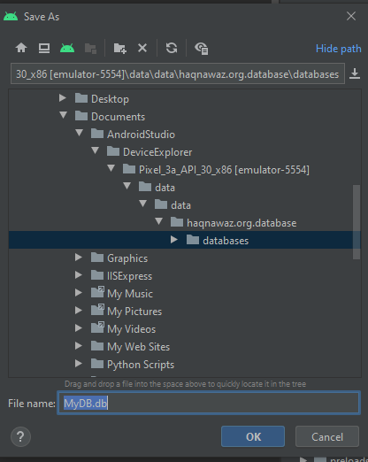

* Now open you SQLite Browser and select the option to open database.

|  |
| --- |
|  |

* Choose the database file you want to open.

|  |
| --- |
|  |

* Here is the database you have opened in your SQLite Browser.

|  |
| --- |
|  |

**LECTURE#11**

**SQLite Lec#3**

* **Retrieving Data from Database:**
* Make a function **getAllRecords()** will return a list of type customer model.

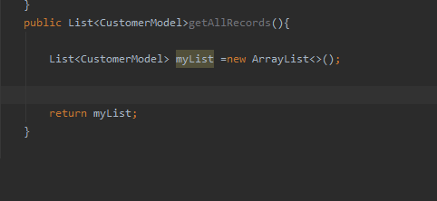

**Define Query:**

* Define the following query to retrieve data from database.

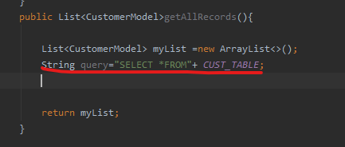

* **Make an object of SQLite Database:**
* To get record make an object of database.

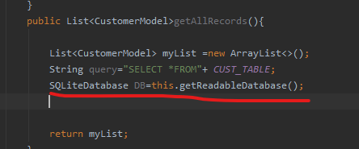

* **Curser:** used to return dataSet.(kind of a table)
* Define **rawQuery()** that will return us a cursor as dataset.

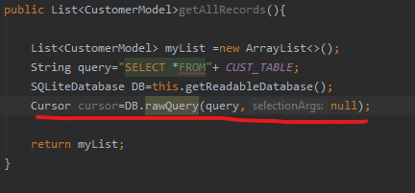

* **Checks and place records:**
* Place a check in if condition to check if records are available, then get them.

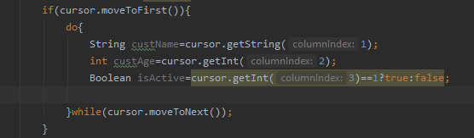

* **Using Model:**
* Now define a customer class model to get its values to database.

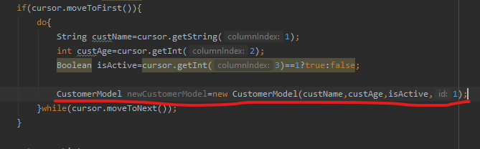

* **Adding to list:**
* Add values of model to list in order to display them.

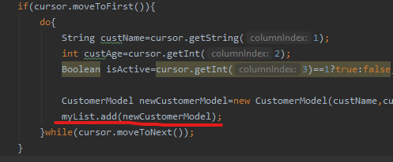

* **Closing Resources after use:**
* Close the used resources after getting values from them.

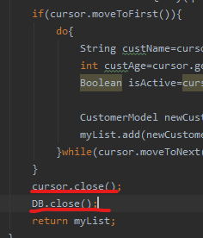

* **Add DB Helper & List:**
* OnClick() Add DBHelper and list so we can get values from databse on click.

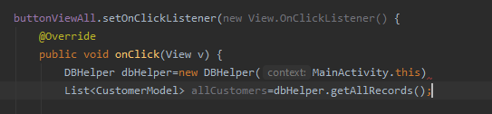

* **Displaying in toast:**
* Use a toast to check if values are being added on click of add button.

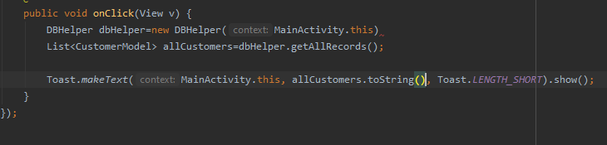

* Click on add value then view record

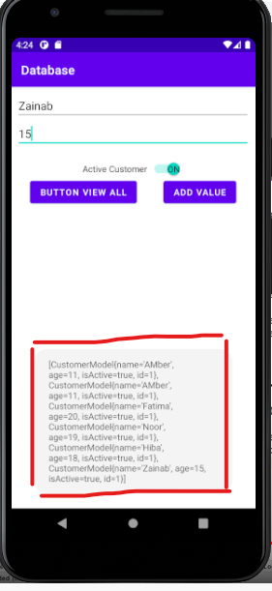

* **To Display in ListView:**
* List is made so make a new array adapter to show it.

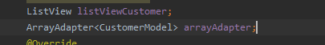

* Pass customer class values to array adapter then pass adapter to list to get displayed.



* Now as we run the emulator we can see values being displayed in list on clicking add value.

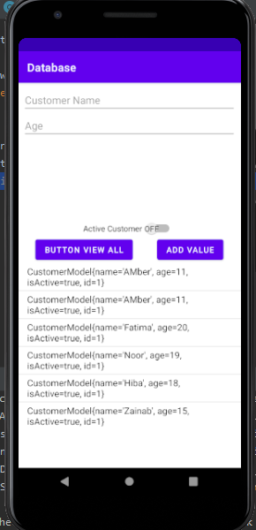

* List is not displayed in scroll view properly so reset its constraints.

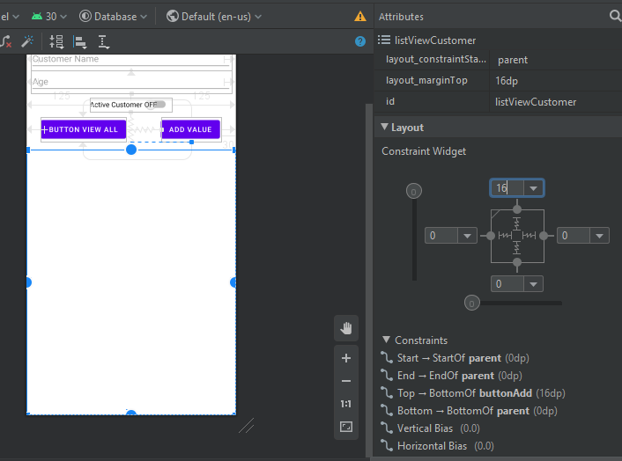.

* After setting constraints rerun the emulator and see a scrolling view of the records being displayed in list.

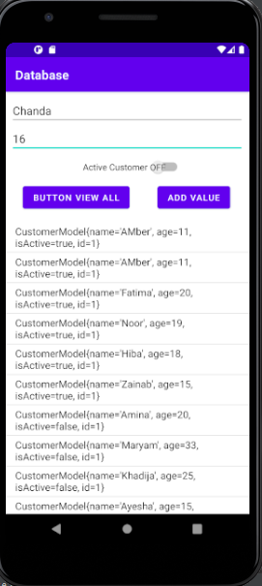

* **Refactor Method:**
* To refactor method follow the steps bellow.

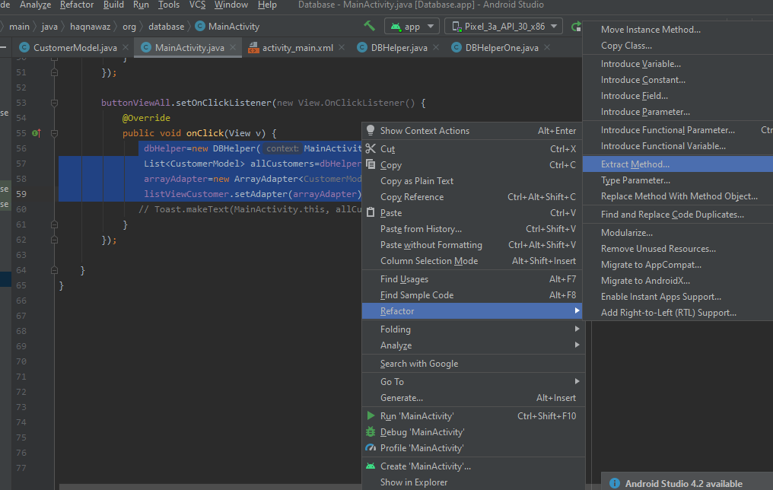

* Choose the activity where you want to refactor.

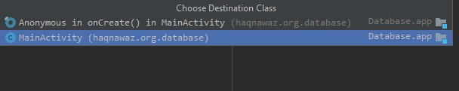

* Select a return type name for the method to be refactored.

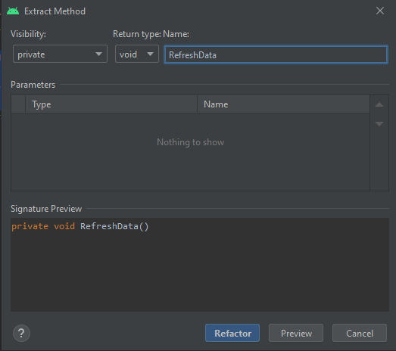

* Now instead of using all the statements just call the refactored method in click function.

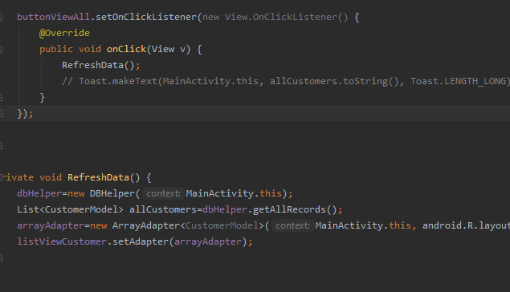

* **Refresh on Add new record:**
* Also add refactor method to on click try so record being added to list when clicked.

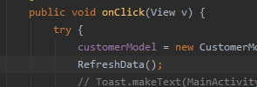

* **Refresh on OnCreate:**
* Also add refactor method to on create so record being displayed not just on adding but also on first view of screen too.

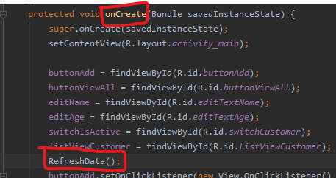

* Run the emulator and see the previous records on screen without even adding a new one.

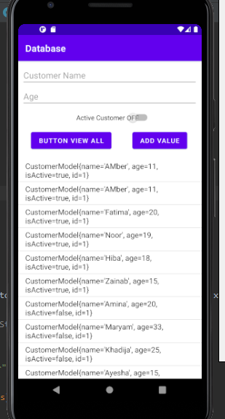

* **Bug:**
  + New Record added is displayed in list not on clicking add value but after clicking view all records.

**Add value=>** no record show **……….... View all =>** record added show

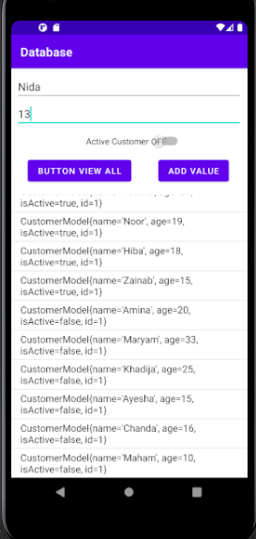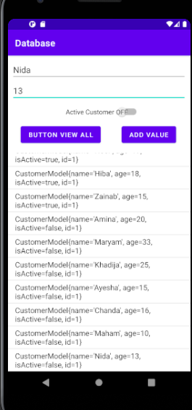

* **Remove Bug:**
  + Add refresh method just after the values are being added to list.

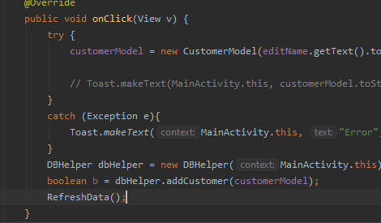

* Run th emulator and see ,Record displayed on clicking add value.

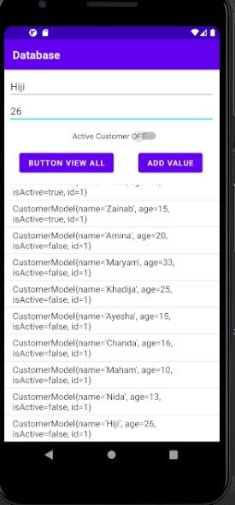

* **To make changes in database:**
* Open SQLite Browser, open your database and do the step bellow.

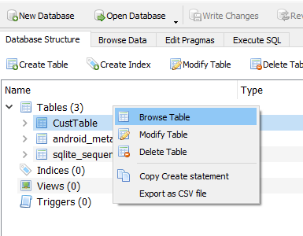

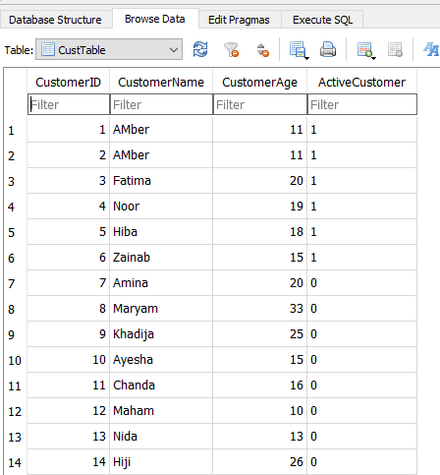

**Homework TASKS:**

1. BUG=>Update id at data retrieval
2. On click delete record

**LECTURE#12**

**Drawer Navigation:**